Task 1
Name: __________________
Resource A | Picture 1 | Picture 2 | Picture 3
What you can see?

What you could hear if you were there?

What would you touch? What would it feel like?

What would you taste? What would it taste like?

How would you feel?

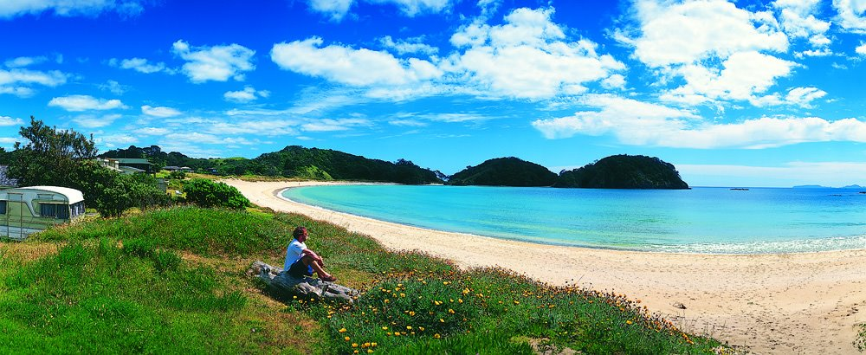

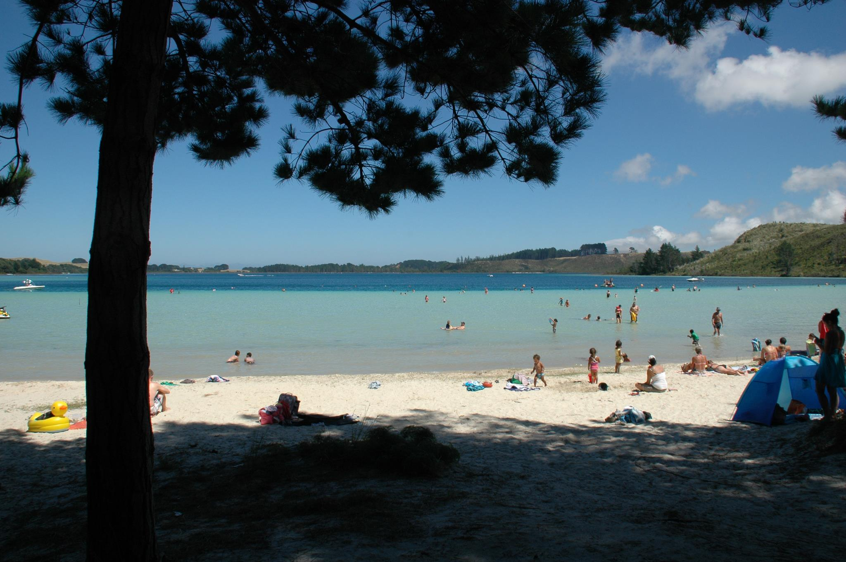

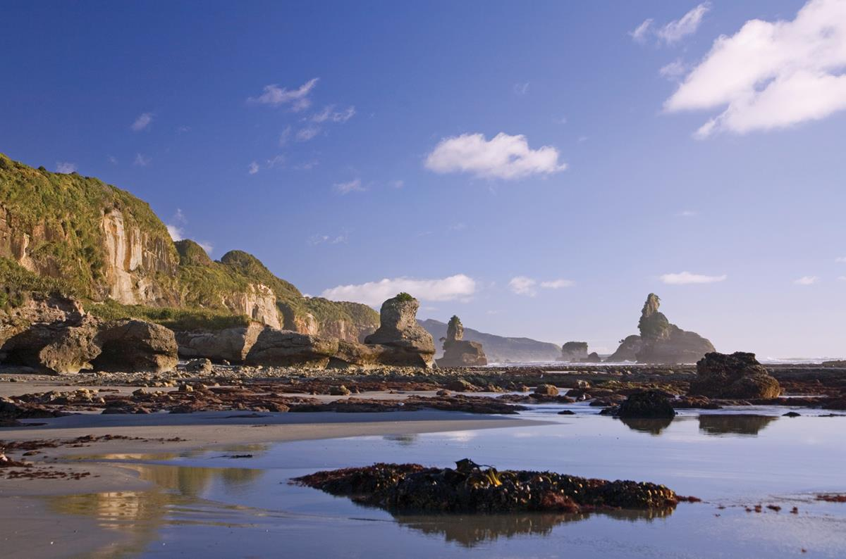

Task 2
Words to describe the things you see and what is happening. Use words from this table
Golden, glowing, cool, wet, patiently, anxiously, moist, clear, hazy, turquois coloured, slippery, jagged, dangerous, noiselessly, brightly coloured, leisurely, unhurriedly, relaxingly, furiously, feverishly, quietly, swiftly, carefully, eerily, sunlit, pale red, bright red, blood red, glamorous, trendy, beautiful, expensive, luxurious, brightly coloured, colourful, light green, olive green, wilting, plump, firm, fresh, casually, nonchalantly, grey-haired, carefully, cautiously, glimmering, bright, sunny, cloudless, exuberantly, excitedly, loudly, gently, gradually.

