Task 1
Watch: Otago Boar Hunting Video Clip and answer the following questions

- What is the purpose of the opening scenes of the ute driving up and down the hills?

_______________________________________________________________________________________________________________________________________________________________________________________________________________________________________________________________

- What is the purpose of the close up shot of the grass / vegetation?

_______________________________________________________________________________________________________________________________________________________________________________________________________________________________________________________________

- What impression do you get from the shakiness of the hand held camera shot?

_______________________________________________________________________________________________________________________________________________________________________________________________________________________________________________________________

- Why do we see a few slow-motion shots in this video?

_______________________________________________________________________________________________________________________________________________________________________________________________________________________________________________________________

- Why does the video end with another shot of the hawk?

_______________________________________________________________________________________________________________________________________________________________________________________________________________________________________________________________

Film Techniques
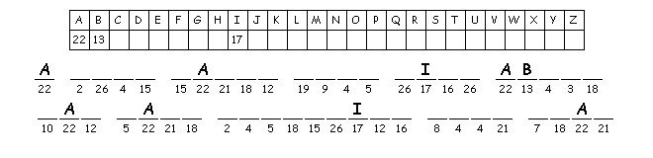

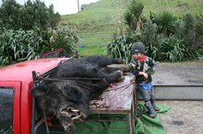
Task 2
The ultimate outdoor man

By Geoff Thomas

Shem Vallis is not overly impressed with his dad's big boar.
All 4-year-old Shem Vallis wanted to do was to go pig-hunting with his father. So when dad Solly Vallis brought home one of the biggest Captain Cookers seen in the country, young Shem was quick to jump on the back of the ute and check it out.
The wild black pigs are descended from animals introduced by Captain Cook in 1769. But few ever get to grow as large as this one did at 135kg.
Vallis caught it while hunting in the backblocks of Taranaki and it gave his two dogs quite a challenge.
But he ended up sitting on the boar and finishing it off with his knife.

Vallis is happy for his sons to follow him on the pig trail. "So long as they don't want to be base-jumpers," said this adventurer who has clocked 10,000 tandem sky-dive jumps and hundreds of base-jumps.
"After going to 21 funerals of mates who were base-jumpers, that is enough for me."
He was the first base-jumper to make it from the west coast to the east coast of the North Island after jumping out of a helicopter in the Far North.

Vallis used to carry a video camera while hurtling through the air and shoot footage for Red Bull commercials but now he is happy to hunt pigs with customers who pay for the experience.
He also has orders from the Animal Health Board which wants heads of pigs from throughout the country to check for Tb.
When he is not hunting, Vallis is following the surf and recently returned from a month in Hawaii.
The Gold Coast is next on the itinerary, but he can grab one of the surfboards lining the wall of his home on the south Taranaki coast at any time, with some of the country's best breaks hitting only a few hundred metres from his house.

When the surf is not crashing on the rocks he throws the dive gear into his tinnie and heads out to find a crayfish for dinner.
"You can usually find bugs of 2kg or 3kg in less than 20m."
This winter has been a good one for fishing off the rocky coast, with big snapper running. "And we have even been getting hapuku in 100m," he says. "Got one of 32kg the other day."

When the stags start roaring in the autumn Vallis picks up his clients and heads into the Ruahines or drives to Whakatane to hop on a mate's helicopter to zip into the hills.
His customers scored seven big stags in the roar this year. "I didn't have to pick up a rifle," he says.
"They shot them all."
It can be a problem figuring out what to do on a clear morning when the roar of the surf carries over the sand dunes, the pig dogs are whining eagerly in their kennels and the deer are coming on to the bush edges to feed.
"This country is a real paradise," says Vallis.

Questions / Activities

- What is the heading and what does it tell us about the story? __________________________________________________________________________________________________________________________________________
- Who wrote this story and when was it written? __________________________________________________________________________________________________________________________________________
- Where did Solly catch the pig and how did he finally kill it? Describe: ____________________________________________________________________________________________________________________________________________________________________________________________________________________________________________________________________________________
- What is the main idea in the second paragraph and how can we tell? ____________________________________________________________________________________________________________________________________________________________________________________________________________________________________________________________________________________

- What did Solly do for Red Bull and what does he do now? __________________________________________________________________________________________________________________________________________
- What is the most dangerous activity and what proof does Solly give for the danger associated with this activity? ____________________________________________________________________________________________________________________________________________________________________________________________________________________________________________________________________________________
- What other activities does Solly like to do apart from hunting? ____________________________________________________________________________________________________________________________________________________________________________________________________________________________________________________________________________________

- Explain Solly’s problem. (Final paragraph) ____________________________________________________________________________________________________________________________________________________________________________________________________________________________________________________________________________________

- Fill in the gaps
______ Vallis is an adventurous ______ bloke who ______ to hunt wild pigs and ______ as well as ______ and fishing. He is also a ______ jumper which is when you ______ off a high object such as a cliff or bridge with a ______. The ______ that ______ caught weighed 135 kg. He talks about ______ for crayfish which he calls ______ and says you can ______ 2kg or 3kg sized bugs in ______ than ______ metres of ______. He also takes clients out hunting wild ______ in the roar, which is the name for ______ mating ______ of deer. He says that this ______ is a real __________.

S S O D L L Y I W S A T H R I L L G E S
E I E K E E R H I K A N A R A T A N A N
C D L A H S A U N S T I R A O R E I G S
T A R L G K C A H T T H E R E R O L E U
I F P U A O U E K I C L I E N T S T R R
N U C T A V M I N P A R A D I S E R L F
N G A S A V Y E M D G T W F Q W V U Y B
I N T J A I R L D P E G N E L L A H C O
E U G L X A N T L Q R D V W E W U A J A
Y V L F R Z K C O O V E R F H Y Q W Y R
Y I P Y G L U L O A S C S U R I R A L D
S L A I C R E M M O C I U S A Y N I P R
H E L I C O P T E R K K R S E H N I A H
G N I P M U J E S A B E R V T D I O N F
G N I R U G I F J A D E R H B O B N I G
H U N T I N G C V B P I A S V D M S E J
F O O T A G E J U P F P T Y L U H E B S
C O U N T R Y L A L U A F I T I K B R E
L B N Y H N L N E K G N W U N C S X O S
R V A X O L S P U I C X A G M C X K F G

AUTUMN
BASE JUMPING
CAPTAIN COOKERS
CHALLENGE
CLIENTS
COAST
COMMERCIALS
COUNTRY
CUSTOMERS
DESCENDED
EAGERLY
FIGURING
FISHING
FOOTAGE
PARADISE
RED BULL
RIFLE
ROAR
SOLLY VALLIS
STAG
SURF BOARD
TARANAKI
TINNIE
WHAKATANE
WHINING
WILDBOAR
HAPUKU
HAWAII
HELICOPTER
HUNTING
HURTLING
IMPRESSED
ITINERARY
RUAHINES
SHEM VALLIS
SNAPPER

__ __ __ __ __ __ __ __ __ __ __ __ __ __ __ __ __ __ __ __ __ __ __

__ __ __ __ __ __ __ __ __ __ __ __ __ __ __

Task 3
Read the story ‘Cor Blimey.
- Write down the story title and author’s name.
__________________________________________________________________________________________________________________________________

- In one sentence, summarise what the story is about.
This story is about…_________________________________________________
__________________________________________________________________________________________________________________________________

- What did you think about the story and why?
__________________________________________________________________________________________________________________________________

- What sounded real and why?
__________________________________________________________________________________________________________________________________

- What made you laugh and why?
__________________________________________________________________________________________________________________________________

- What was suspenseful or dramatic?
__________________________________________________________________________________________________________________________________

- Describe the dogs:
- Bud : ____________________________________________________________

- Smoke: __________________________________________________________

- Write down 5 words or phrases that would be examples of slang or colloquial language.
__________________________________________________________________________________________________________________________________
__________________________________________________________________________________________________________________________________
Task 4
Read the story ‘Critter’
- Write down the title and author’s name.
____________________________________________________________________________________________________________________________________

- Summarise what the story is about:
This story is about…
__________________________________________________________________________________________________________________________________

- How much did Critter cost?
____________________________________________________________________________________________________________________________________

- How old was he when the narrator got him ?
____________________________________________________________________________________________________________________________________

- What was the dog’s name at the start? Why did the narrator re-name him?
____________________________________________________________________________________________________________________________________

- What was Critter’s colour and markings?
____________________________________________________________________________________________________________________________________

- The narrator thought that Critter was a le_ _ _ _ in the _ _ _ _ _ _.

- Where was Critter first introduced to the art of pig hunting?
____________________________________________________________________________________________________________________________________

- What was Critter’s specialty?
____________________________________________________________________________________________________________________________________

- What did the huge boar do to Critter? Two injuries inflicted:
____________________________________________________________________________________________________________________________________

- What was amazing about what Critter did at the end of the story?
____________________________________________________________________________________________________________________________________

- What ultimately happened to Critter?
____________________________________________________________________________________________________________________________________

- Write about a special animal you know about or have owned. What were they like and what was special about them? (50 words)
____________________________________________________________________________________________________________________________________
____________________________________________________________________________________________________________________________________
____________________________________________________________________________________________________________________________________
____________________________________________________________________________________________________________________________________
____________________________________________________________________________________________________________________________________

- What do you think are the essential qualities for a pig-hunting dog?
____________________________________________________________________________________________________________________________________

- Do you need different qualities in a bird-hunting dog? What are they and why?
____________________________________________________________________________________________________________________________________

- Write down what you think might have been going through Critter’s mind when he had this encounter with the huge boar.
____________________________________________________________________________________________________________________________________

Task 5
Read the story: ‘Dog Day Night Fright’
- Who is the narrator? (the person telling the story)
__________________________________________________________________________________________________________________________________

- Who is the dog’s master?
__________________________________________________________________________________________________________________________________

- Who is the master’s mate?
__________________________________________________________________________________________________________________________________

- What is the female dog’s name?
__________________________________________________________________________________________________________________________________

- Why does the dog “feel a heap lighter”? Why is that important?
__________________________________________________________________________________________________________________________________

- Write down the simile used on p78 to describe how the dog would feel if there were other dogs in the box as well.
- __________________________________________________________________________________________________________________________________

- How does Mya feel about the dog? How do you know? (look at the picture on p 78)
__________________________________________________________________________________________________________________________________

- Why does Bruce put radio-controlled tracking collars on the dogs?
__________________________________________________________________________________________________________________________________

- What does “GPS” stand for?
__________________________________________________________________________________________________________________________________

- What do you think happened to Rastus?
__________________________________________________________________________________________________________________________________

- What does the dog mean on p83 when he says “no ways are my berries going to shrivel to nothing”?
__________________________________________________________________________________________________________________________________

- Where do the dogs grab the boar?
__________________________________________________________________________________________________________________________________

- What does it mean to “get your a into g”?
__________________________________________________________________________________________________________________________________

- Why is the dog glad that Bruce is not going to try using his rifle? (p 88)
__________________________________________________________________________________________________________________________________

- Look at the picture on p90. How is the dog feeling and why?
__________________________________________________________________________________________________________________________________

- Why do you think the story is called “Dog Day Night Fright”?
__________________________________________________________________________________________________________________________________

- Create a different title for the story.
__________________________________________________________________________________________________________________________________

- What do you think about the use of illustrations? Did it make it easier to understand the story? Did it make it more interesting? Explain your answer.

__________________________________________________________________________________________________________________________________

Vocabulary:
To describe place:
Mountain, hill , steep, bush-covered, rocky, slippery, rough, rugged, wild, stream, creek, river,
______________________________________________________________________________________________________________________________________________
To describe time of day:
______________________________________________________________________________________________________________________________________________
______________________________________________________________________________________________________________________________________________

To describe weather:
______________________________________________________________________________________________________________________________________________
______________________________________________________________________________________________________________________________________________

To describe temperature:
______________________________________________________________________________________________________________________________________________
______________________________________________________________________________________________________________________________________________

To describe ground plants:
______________________________________________________________________________________________________________________________________________
______________________________________________________________________________________________________________________________________________

Task 6
Watch: ‘This Way of Life’
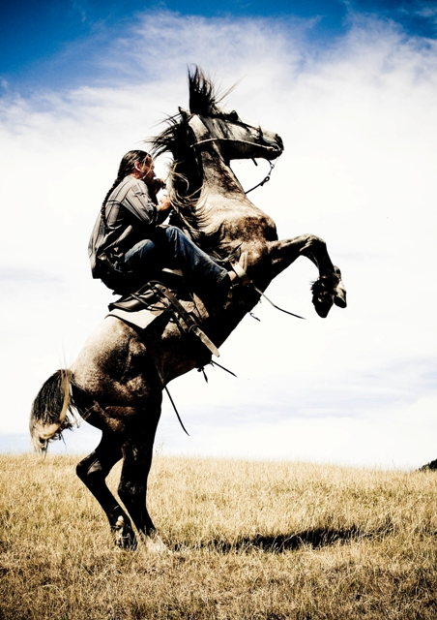
This is a true story (documentary) about the Karena whanau - Peter, Colleen and their six children - who live in-land from Haumoana in the Hawkes Bay. The father hunts in the Ruahine Ranges.
The style of filming is cinema verité = cinema truth – a method of filming something to show candid truth – filming ordinary people in actual activities – often using hand-held cameras and light-weight equipment.
The film opens with the oldest boy listening at dawn to rifle shots echoing around a remote mountainous valley – he says it sounds like a war – then he recognises the sound of his father’s gun.
His father and another man return with two hinds which have already been field-dressed (heads and hooves removed, gutted).
The father later explains why he cuts up whole deer at his home. It is so that his children know where their food comes from. He tells the story of his youngest seeing his first shot deer – it was still kicking – the boy was sad but then said, “It’s o.k. ‘cos it died so we could live.” The father wants his children to have respect for the animals which sustain them.
Colleen Karena is very attached to the Karena family home – it’s 100 years old and has had 7 generations of family pass through it. The gallery of photographs on the wall are very important. There is a urupa (cemetery) close by which has many of the Karena family buried there – some were with the 28th Maori Battalion. When we first see her, Colleen says he has had five children under five and is pregnant with the sixth. She wants more children.
We learn that there is a dispute between Peter Karena and his father. Peter can’t buy the house. His father ‘sells’ it to someone else although later it turns out that it is not a valid sale.
Police are called when trouble erupts when Peter’s father tries to get his heavy friends to force Peter and Colleen out. The police take Peter’s firearms. He does not lose his temper although he is clearly frustrated and angry. He says that he does not want to bring violence into the home.
When the family are forced out, they go to live in a caravan. Idyllic days are spent horse riding in the river, riding across the dunes and the beach. It’s a simple way of life. They have no major material comforts but they’re happy.
Later they move into a shed after staying with Colleen’s mother for a time – the kids are happy to have their own place.
Peter reveals how attached he is to his sixth child, daughter Salem, who was born as the troubles around the house were bearing down. He believes she “came at the right time” to “save his soul” from the anguish he was going through. Peter believes all his children came at the right time, but feels a special bond with her.
The family experience tragedy and hardship but stay strong. They go to Church together on Sunday. Peter is clear that he does not want his kids to see any violence. He tries to bring up his kids the way he would have wanted to be brought up.

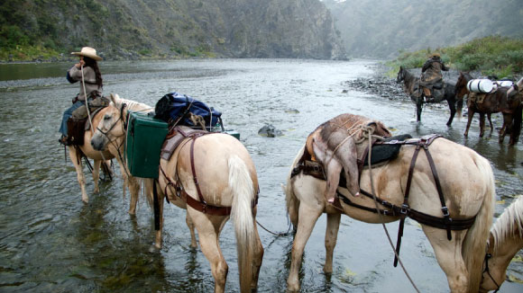

Task 6
Personal Response to the film This Way of Life
- What is the film about? Sum it up in a paragraph.
________________________________________________________________________________________________________________________________
________________________________________________________________________________________________________________________________

- What were some images that made an impact on you? Explain why.

e.g. Opening shot at dawn in the mountains? Riding bareback in the river? How small the kids are on horseback? The photos on the wall of the living room? The loss of the house through fire? Camping in the caravan?
________________________________________________________________________________________________________________________________
________________________________________________________________________________________________________________________________

- Have you ridden a horse before? With or without a saddle? When? Describe the experience.
________________________________________________________________________________________________________________________________
________________________________________________________________________________________________________________________________

- Have you camped out? When? Describe the experience.
________________________________________________________________________________________________________________________________
________________________________________________________________________________________________________________________________

- Have you been in a house like the Karenas? When? Describe the experience.
________________________________________________________________________________________________________________________________

- What are Peter Karena’s personal beliefs (philosophy) about hunting?
________________________________________________________________________________________________________________________________
________________________________________________________________________________________________________________________________

- What are your views about hunting? Give reasons for your opinion.
________________________________________________________________________________________________________________________________
________________________________________________________________________________________________________________________________

- The Karenas lost many of their possessions in the house fire. The thing that seems to bother Colleen most is the loss of family photographs. Why does she feel this way?
________________________________________________________________________________________________________________________________

- What would you do if your own house was destroyed by fire? What would you miss the most? What would you try to save and why?
________________________________________________________________________________________________________________________________

- Peter Karena breaks in horses and runs a horse trekking business. He explains his method of breaking in a horse. Outline how he does it and write down your opinion about his method. Do you agree with his approach? Why?
________________________________________________________________________________________________________________________________
________________________________________________________________________________________________________________________________

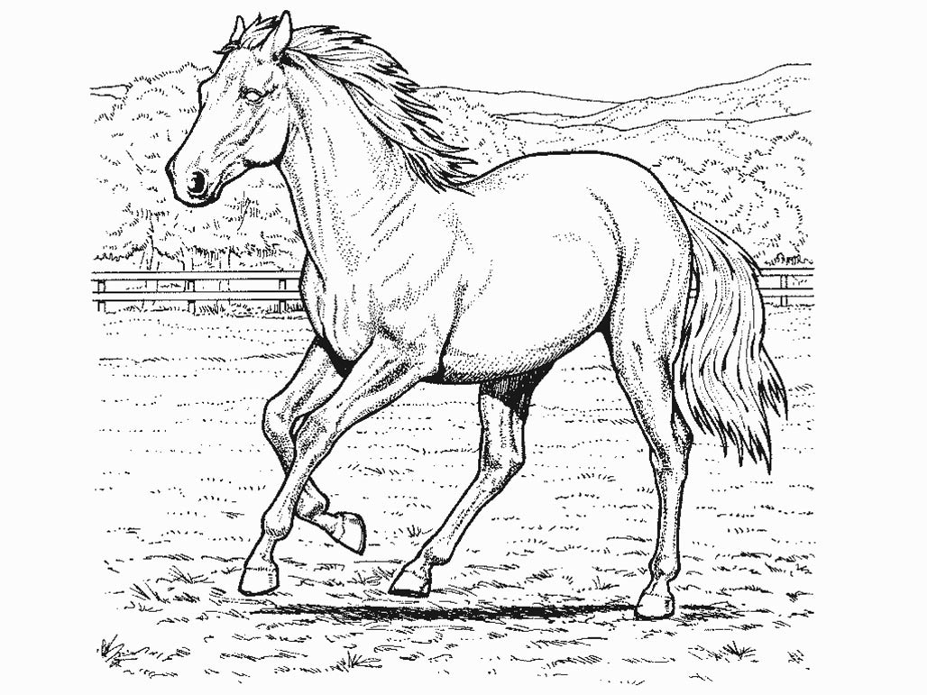
- Colour in the horse:
- How did you feel when you saw the kids galloping their horses? Describe what the kids might have been experiencing as they raced along using the five senses:

- Sight

- Sound

- Touch

- Taste

- Smell

- What might be going through their minds as they raced?
________________________________________________________________________________________________________________________________

Task 7

Hunting Pigs in New Zealand
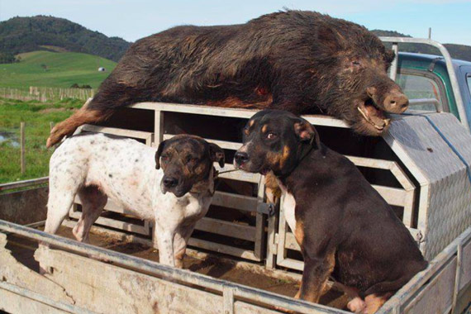
If numbers are not efficiently controlled, ____________ pigs in New Zealand can be a problem because they eat a wide range of ____________, and root up the ground, causing soil disturbance. They increase in _________________ rapidly, and control of their population is helped by _______________ hunters. When hunting pigs, the most popular method is ________________, which uses specially trained dogs and involves sticking the bailed pig with a knife, but hunters can foot stalk pigs and shoot them with a ____________.
Wild boars are challenging to hunt, as not only are they large with sharp________, but they have a good sense of smell, and good _________________. The method of pig sticking can be ___________________ and risky, which is part of the appeal. Pig hunting is a large _____________ in New Zealand, with many pig hunting clubs around the country.

Pig Hunting Tips
- You can hunt pigs all year round in New Zealand, but ____________ is usually the best for successful pig hunting.
- The best time to hunt pigs is at __________ and at dusk as they are more likely to be on the edge of the shrub or bush. Pigs tend to have tracks running through dense scrub which can prove hard for both hunters and dogs to negotiate.
- Pigs will often come out to the edge of farms in the spring as they feed on ______________ and calf placenta. They will also kill ____________ lambs.
- Because pigs have excellent hearing and a good sense of smell, hunters should stay ______________ and remain quiet.
- If using the foot stalking method, try kill the pig on the first shot. Feral pigs are aggressive and if wounded there is a chance they could ____________ at you.
- Train your dogs well before taking them out on a hunt for the first time. Make sure you have the appropriate _____________ and speak with others in the know on how to ____________ dogs.
- Even if you are pig sticking, it’s a good idea that someone in the hunting __________ carries a gun for shooting pigs that could possibly put yourself or your dogs in danger.
- When shooting a large pig, make sure you use an appropriate calibre rifle. Some popular _____________ are .44 magnum, .303, and .308. Smaller calibres may not be large enough to humanely kill the pig.

recreational
lamb
sport
breeds
party
rifle
charge
train
down-wind
calibres
tusks
winter
pig sticking
new-born
dawn
unpredictable
hearing
vegetation
feral
numbe

Dogs
Find and circle all of the words that are hidden in the grid.
The remaining letters spell an Ogden Nash quotation.
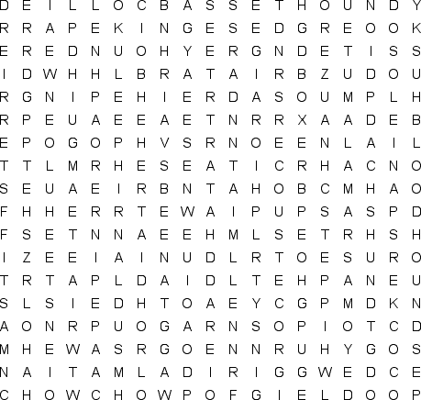
BASSET HOUND  BEAGLE  BLOODHOUND  BOXER  BULLDOG  CHIHUAHUA  CHOW CHOW  COCKER SPANIEL  COLLIE  CORGI |  | DACHSHUND  DALMATIAN  DEERHOUND  DINGO  GERMAN SHEPHERD  GREAT DANE  GREYHOUND  HUSKY  LHASA APSO  MALAMUTE |  | MASTIFF  PEKINGESE  PINSCHER  POINTER  POMERANIAN  POODLE  PUG  RETRIEVER  ROTTWEILER  SAINT BERNARD |  | SAMOYED  SCHNAUZER  SETTER  SHAR PEI  SHEEPDOG  SPITZ  TERRIER  WHIPPET

Farm
Find and circle all of the words that are hidden in the grid.
The remaining letters spell a common farm animal.
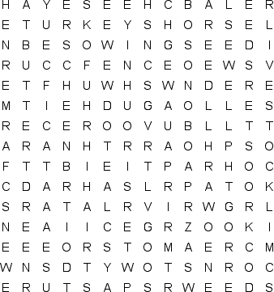
BALER  BARN  BUTTER  CAT  CHEESE  CORN  COW  CREAM  DAIRY  DOG |  | FARMER  FENCE  FERTILIZER  GOATS  GRAIN  HARROW  HARVEST  HAY  HEN  HORSE |  | HOUSE  LIVESTOCK  MILK  PASTURE  PIG  PLOW  PRODUCE  ROOSTER  SEEDS  SOIL |  | SOWING SEED  STABLES  TRACTOR  TROUGH  TURKEYS  WEATHERVANE  WEEDS  WELL  WHEAT

F O O D
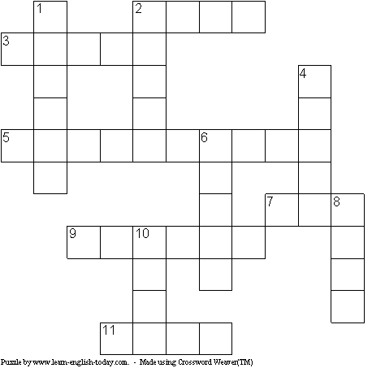

Across | Down
2) Found in rivers and seas  3) Sweetens food  5) Potatoes, carrots, for example  7) Made from fruit and sugar  9) Eaten for breakfast  11) Source of proteins, red or white | 1) You can spread it on bread  2) Often grows on trees  4) Popular in Italy  6) Needed for sandwiches  8) Babies drink a lot of this  10) Eaten a lot in Asia

