The Outsiders

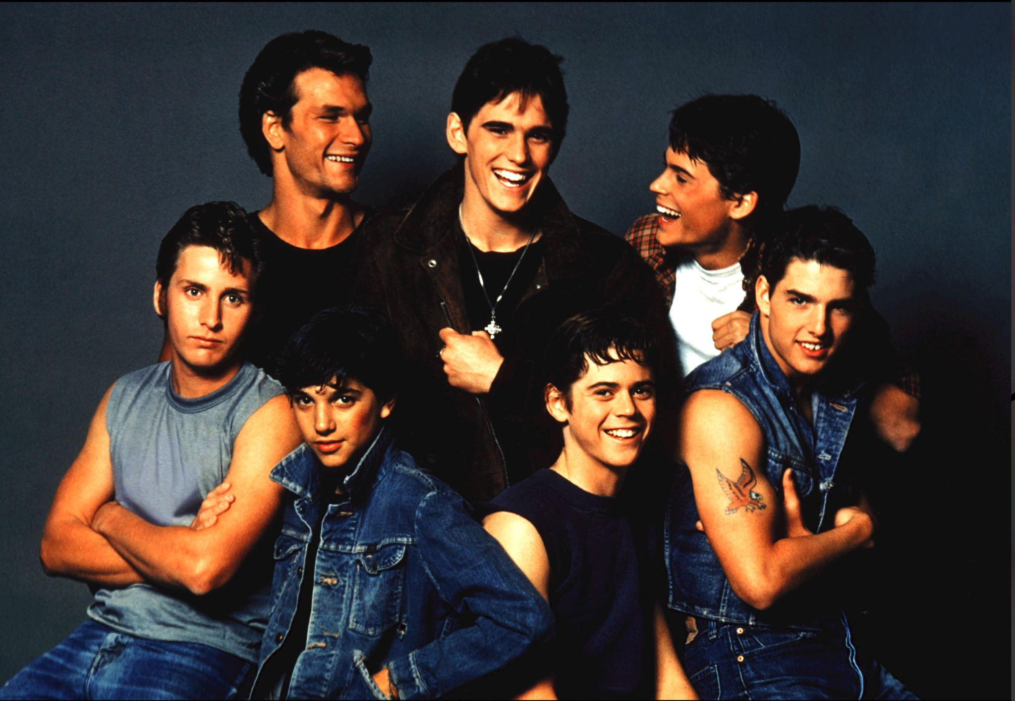

Name: \_\_\_\_\_\_\_\_\_\_\_\_\_\_\_\_\_\_\_\_\_\_\_\_\_\_\_\_\_\_

**Student Activity**

**Design a new cover (static image) for the book.**

* **Your static image must reflect the main idea(s) or message(s) you have identified in your chosen text.**
* **You must include a short relevant quotation or words linked to the text which reinforce the idea(s) in your image.**
* **Your static image must be produced on A4 paper.**
* **Layout should be portrait.**
* **You must write a commentary of up to 250, explaining the choices you have made in constructing your image and how it relates to the text of The Outsiders**

**You will be assessed on**

* **how well you communicate your ideas to your audience**
* **the appropriateness and effectiveness of your verbal and visual techniques**
* **how clearly you identify and explain the techniques you have used in your static image**

**Activity 1**

**Skippy Cornflakes**

A lot of thought has been given to the way the information on this packet is shown. It has been designed to look good so that it will catch people's attention. It has also been designed to give certain messages to people about eating Skippy Cornflakes.

1. First of all, see if you can tell me the ways used to make the packet **look good** and interesting – so that people will want to look at it. Look carefully at both sides of the packet to help you with your answer.

\_\_\_\_\_\_\_\_\_\_\_\_\_\_\_\_\_\_\_\_\_\_\_\_\_\_\_\_\_\_\_\_\_\_\_\_\_\_\_\_\_\_\_\_\_\_\_\_\_\_\_\_\_\_\_\_\_\_\_\_\_\_\_\_\_\_\_\_\_\_\_\_\_\_\_\_\_\_\_\_\_\_\_\_\_\_\_\_\_\_\_\_\_\_\_\_\_\_\_\_\_\_\_\_\_\_\_\_\_\_\_\_\_\_\_\_\_\_\_\_\_\_\_\_\_\_\_\_\_\_\_\_\_\_\_\_\_\_\_\_\_\_\_\_\_\_\_\_\_\_\_\_\_\_\_\_\_\_\_\_\_\_\_\_\_\_\_\_\_\_\_\_\_\_\_\_\_\_\_\_\_\_\_\_\_\_\_\_\_\_\_\_\_\_\_\_\_\_\_\_\_\_\_\_\_\_\_\_\_\_\_\_\_\_\_\_\_\_\_\_\_\_\_\_\_\_\_\_\_\_\_\_\_\_\_\_\_\_\_\_\_\_\_\_\_\_\_\_\_\_\_\_\_\_\_\_\_\_\_\_\_\_\_\_\_\_\_\_\_\_\_\_\_\_\_\_\_\_\_\_\_\_\_\_\_\_\_\_\_\_\_\_\_\_\_\_\_\_\_\_\_\_\_\_\_\_\_\_\_\_\_\_\_\_\_\_\_\_\_\_\_\_\_\_\_\_\_\_\_\_\_\_\_\_\_\_\_\_\_\_\_\_\_\_\_\_\_\_\_\_\_\_\_\_\_\_\_\_\_\_\_\_\_\_\_\_\_\_\_\_\_\_\_\_\_\_\_\_\_\_\_\_\_\_\_\_\_\_\_\_\_\_\_\_\_\_\_\_\_\_

1. The packet has been designed to give certain **messages** about eating Skippy Cornflakes. What do you think these messages are? Look at both sides of the packet to help you with your answer.  
   \_\_\_\_\_\_\_\_\_\_\_\_\_\_\_\_\_\_\_\_\_\_\_\_\_\_\_\_\_\_\_\_\_\_\_\_\_\_\_\_\_\_\_\_\_\_\_\_\_\_\_\_\_\_\_\_\_\_\_\_\_\_\_\_\_\_\_\_\_\_\_\_\_\_\_\_\_\_\_\_\_\_\_\_\_\_\_\_\_\_\_\_\_\_\_\_\_\_\_\_\_\_\_\_\_\_\_\_\_\_\_\_\_\_\_\_\_\_\_\_\_\_\_\_\_\_\_\_\_\_\_\_\_\_\_\_\_\_\_\_\_\_\_\_\_\_\_\_\_\_\_\_\_\_\_\_\_\_\_\_

\_\_\_\_\_\_\_\_\_\_\_\_\_\_\_\_\_\_\_\_\_\_\_\_\_\_\_\_\_\_\_\_\_\_\_\_\_\_\_\_\_\_\_\_\_\_\_\_\_\_\_\_\_\_\_\_\_\_\_\_\_\_\_\_\_\_\_\_\_\_\_\_\_\_\_\_\_\_\_\_\_\_\_\_\_\_\_\_\_\_\_\_\_\_\_\_\_\_\_\_\_\_\_\_\_\_\_\_\_\_\_\_\_\_\_\_\_\_\_\_\_\_\_\_\_\_\_\_\_\_\_\_\_\_\_\_\_\_\_\_\_\_\_\_\_\_\_\_\_\_\_\_\_\_\_\_\_\_\_\_

**Activity 2**

**The New Zealand Flag**

a) In our newspapers and talkback shows there has been debate over a new flag for New Zealand. Give **one** reason why some think we should change our flag.

\_\_\_\_\_\_\_\_\_\_\_\_\_\_\_\_\_\_\_\_\_\_\_\_\_\_\_\_\_\_\_\_\_\_\_\_\_\_\_\_\_\_\_\_\_\_\_\_\_\_\_\_\_\_\_\_\_\_\_\_\_\_\_\_\_\_\_\_\_\_\_\_\_

\_\_\_\_\_\_\_\_\_\_\_\_\_\_\_\_\_\_\_\_\_\_\_\_\_\_\_\_\_\_\_\_\_\_\_\_\_\_\_\_\_\_\_\_\_\_\_\_\_\_\_\_\_\_\_\_\_\_\_\_\_\_\_\_\_\_\_\_\_\_\_\_\_

b) Give **one** reason for keeping our flag as it is now.

\_\_\_\_\_\_\_\_\_\_\_\_\_\_\_\_\_\_\_\_\_\_\_\_\_\_\_\_\_\_\_\_\_\_\_\_\_\_\_\_\_\_\_\_\_\_\_\_\_\_\_\_\_\_\_\_\_\_\_\_\_\_\_\_\_\_\_\_\_\_\_\_\_

\_\_\_\_\_\_\_\_\_\_\_\_\_\_\_\_\_\_\_\_\_\_\_\_\_\_\_\_\_\_\_\_\_\_\_\_\_\_\_\_\_\_\_\_\_\_\_\_\_\_\_\_\_\_\_\_\_\_\_\_\_\_\_\_\_\_\_\_\_\_\_\_\_

c) Your task is now to redesign the current New Zealand flag.

**Current flag**



Think about a possible new design. You can use the planning box to sketch ideas, consider **colour** and **shapes**.

## Planning box

Final version of your new flag.

Use colour.

d) i) Explain the reasoning behind the **colours** you chose.

\_\_\_\_\_\_\_\_\_\_\_\_\_\_\_\_\_\_\_\_\_\_\_\_\_\_\_\_\_\_\_\_\_\_\_\_\_\_\_\_\_\_\_\_\_\_\_\_\_\_\_\_\_\_\_\_\_\_\_\_\_\_\_\_\_\_\_\_\_\_\_

\_\_\_\_\_\_\_\_\_\_\_\_\_\_\_\_\_\_\_\_\_\_\_\_\_\_\_\_\_\_\_\_\_\_\_\_\_\_\_\_\_\_\_\_\_\_\_\_\_\_\_\_\_\_\_\_\_\_\_\_\_\_\_\_\_\_\_\_\_\_\_

\_\_\_\_\_\_\_\_\_\_\_\_\_\_\_\_\_\_\_\_\_\_\_\_\_\_\_\_\_\_\_\_\_\_\_\_\_\_\_\_\_\_\_\_\_\_\_\_\_\_\_\_\_\_\_\_\_\_\_\_\_\_\_\_\_\_\_\_\_\_\_

\_\_\_\_\_\_\_\_\_\_\_\_\_\_\_\_\_\_\_\_\_\_\_\_\_\_\_\_\_\_\_\_\_\_\_\_\_\_\_\_\_\_\_\_\_\_\_\_\_\_\_\_\_\_\_\_\_\_\_\_\_\_\_\_\_\_\_\_\_\_\_

ii) Explain the reasoning behind the **shapes** you used.

\_\_\_\_\_\_\_\_\_\_\_\_\_\_\_\_\_\_\_\_\_\_\_\_\_\_\_\_\_\_\_\_\_\_\_\_\_\_\_\_\_\_\_\_\_\_\_\_\_\_\_\_\_\_\_\_\_\_\_\_\_\_\_\_\_\_\_\_\_\_\_

\_\_\_\_\_\_\_\_\_\_\_\_\_\_\_\_\_\_\_\_\_\_\_\_\_\_\_\_\_\_\_\_\_\_\_\_\_\_\_\_\_\_\_\_\_\_\_\_\_\_\_\_\_\_\_\_\_\_\_\_\_\_\_\_\_\_\_\_\_\_\_

\_\_\_\_\_\_\_\_\_\_\_\_\_\_\_\_\_\_\_\_\_\_\_\_\_\_\_\_\_\_\_\_\_\_\_\_\_\_\_\_\_\_\_\_\_\_\_\_\_\_\_\_\_\_\_\_\_\_\_\_\_\_\_\_\_\_\_\_\_\_\_

\_\_\_\_\_\_\_\_\_\_\_\_\_\_\_\_\_\_\_\_\_\_\_\_\_\_\_\_\_\_\_\_\_\_\_\_\_\_\_\_\_\_\_\_\_\_\_\_\_\_\_\_\_\_\_\_\_\_\_\_\_\_\_\_\_\_\_\_\_\_\_

iii) What are two reasons for your revised flag being an improvement?

1. \_\_\_\_\_\_\_\_\_\_\_\_\_\_\_\_\_\_\_\_\_\_\_\_\_\_\_\_\_\_\_\_\_\_\_\_\_\_\_\_\_\_\_\_\_\_\_\_\_\_\_\_\_\_\_\_\_\_\_\_\_\_\_\_\_\_\_

\_\_\_\_\_\_\_\_\_\_\_\_\_\_\_\_\_\_\_\_\_\_\_\_\_\_\_\_\_\_\_\_\_\_\_\_\_\_\_\_\_\_\_\_\_\_\_\_\_\_\_\_\_\_\_\_\_\_\_\_\_\_\_\_\_\_\_

\_\_\_\_\_\_\_\_\_\_\_\_\_\_\_\_\_\_\_\_\_\_\_\_\_\_\_\_\_\_\_\_\_\_\_\_\_\_\_\_\_\_\_\_\_\_\_\_\_\_\_\_\_\_\_\_\_\_\_\_\_\_\_\_\_\_\_

2. \_\_\_\_\_\_\_\_\_\_\_\_\_\_\_\_\_\_\_\_\_\_\_\_\_\_\_\_\_\_\_\_\_\_\_\_\_\_\_\_\_\_\_\_\_\_\_\_\_\_\_\_\_\_\_\_\_\_\_\_\_\_\_\_\_\_\_

\_\_\_\_\_\_\_\_\_\_\_\_\_\_\_\_\_\_\_\_\_\_\_\_\_\_\_\_\_\_\_\_\_\_\_\_\_\_\_\_\_\_\_\_\_\_\_\_\_\_\_\_\_\_\_\_\_\_\_\_\_\_\_\_\_\_\_

\_\_\_\_\_\_\_\_\_\_\_\_\_\_\_\_\_\_\_\_\_\_\_\_\_\_\_\_\_\_\_\_\_\_\_\_\_\_\_\_\_\_\_\_\_\_\_\_\_\_\_\_\_\_\_\_\_\_\_\_\_\_\_\_\_\_\_

fl00068_

**Colour Meaning**

**Red**

Red is the colour of fire and blood, so it is associated with energy, war, danger, strength, power, determination as well as passion, desire, and love.

**Light red** represents joy, sexuality, passion, sensitivity, and love.   
**Pink** signifies romance, love, and friendship. It denotes feminine qualities and passiveness.  
**Dark red** is associated with vigour, willpower, rage, anger, leadership, courage, longing, malice, and wrath.  
**Brown** suggests stability and denotes masculine qualities.  
**Reddish-brown** is associated with harvest and fall.

**Orange**

Orange combines the energy of red and the happiness of yellow. It is associated with joy, sunshine, and the tropics. Orange represents enthusiasm, fascination, happiness, creativity, determination, attraction, success, encouragement, and stimulation.

**Dark orange** can mean deceit and distrust.  
**Red-orange** corresponds to desire, sexual passion, pleasure, domination, aggression, and thirst for action.  
**Gold** evokes the feeling of prestige. The meaning of gold is illumination, wisdom, and wealth. Gold often symbolizes high quality.

**Yellow**

Yellow is the colour of sunshine. It's associated with joy, happiness, intellect, and energy.

**Dull (dingy) yellow** represents caution, decay, sickness, and jealousy.   
**Light yellow** is associated with intellect, freshness, and joy.

**Green**

Green is the colour of nature. It symbolizes growth, harmony, freshness, and fertility. Green has strong emotional correspondence with safety. Dark green is also commonly associated with money.

**Dark green** is associated with ambition, greed, and jealousy.  
**Yellow-green** can indicate sickness, cowardice, discord, and jealousy.  
**Aqua** is associated with emotional healing and protection.  
**Olive green** is the traditional colour of peace.

**Blue**

Blue is the colour of the sky and sea. It is often associated with depth and stability. It symbolizes trust, loyalty, wisdom, confidence, intelligence, faith, truth, and heaven.

**Light blue** is associated with health, healing, tranquillity, understanding, and softness.  
**Dark blue** represents knowledge, power, integrity, and seriousness.

**Purple**

Purple combines the stability of blue and the energy of red. Purple is associated with royalty. It symbolizes power, nobility, luxury, and ambition. It conveys wealth and extravagance. Purple is associated with wisdom, dignity, independence, creativity, mystery, and magic.

**Light purple** evokes romantic and nostalgic feelings.  
**Dark purple** evokes gloom and sad feelings. It can cause frustration.

**White**

White is associated with light, goodness, innocence, purity, and virginity. It is considered to be the colour of perfection.

**Black**

Black is associated with power, elegance, formality, death, evil, and mystery.

Black is a mysterious colour associated with fear and the unknown (black holes). It usually has a negative connotation (blacklist, black humour, 'black death'). Black denotes strength and authority; it is considered to be a very formal, elegant, and prestigious colour (black tie, black Mercedes). In heraldry, black is the symbol of grief.

**Activity 3**

**Symbols we Use**

Add meaning to the symbols provided and draw your own to complete the table

|  |  |
| --- | --- |
| Symbol | Meaning |
| http://www.kiwistamping.co.nz/Files/E73_Silver_Fern.gif |  |
| http://2.bp.blogspot.com/-Efcg8gpjnx4/ThwRhxsc9CI/AAAAAAAAAqQ/ih4An8JDAXo/s1600/Rose%2Bflower%2Bcoloring%2Bpages%2B1.gif |  |
|  |  |
|  |  |
|  |  |
|  |  |
|  |  |
|  |  |
|  |  |
|  |  |

**Planning**

**The static image needs to reflect a main idea from the text.**

**Get a relevant quote from the text to support this idea.**

**Decide what visual and verbal techniques you will use and what is the intended effect?**

**Make the following decisions before you do a draft of your static image.**

|  |  |
| --- | --- |
| **Visual Technique** | **How am I using it and the Effect I have in mind** |
| **Dominant feature** |  |
| **Layout/Balance** |  |
| **Colour** |  |
| **Lettering – style/size** |  |
| **Proportion** |  |
| **Movement** |  |
| **Depth** |  |
| **Symbols** |  |

|  |  |  |
| --- | --- | --- |
| **Verbal Technique** | **Detail – to be used where** | **Intended Effect** |
| **Figures of Speech** |  |  |
| **Vocabulary** | **(Your selected quote)** |  |
| **Grammar** |  |  |
| **Tone** |  |  |

You might like to use the following sentence starters to help you write your commentary:

**Guidelines for Written Explanation of Static Image**

My static image portrays the idea that….I have shown this by….My static image is……………………and the intended audience is…………………………..The visual elements I have used include….The main idea I wanted to convey was……………………………The dominant image is………………………………….because……………..I have used the colours …I used [……..colour] to show………………………[Explain why each of the colours were used]

The symbols I used were…………….because………………………………. [Explain why each of the images were used]. The layout of the image is effective because…………..The quotation or words I have chosen are relevant because…The font/lettering I have used is………………….. The effect I wanted the font/lettering to give was…………………………………………………….

My image is effective because ………………………………………………

Evaluation Sheet: Static Image Year 10

|  |  |  |  |  |  |  |  |  |  |  |
| --- | --- | --- | --- | --- | --- | --- | --- | --- | --- | --- |
| Communicates  - straightforward ideas /  - developed ideas /  - fully developed ideas /  for a specific audience and purpose. | 1 | 2 | 3 | 4 | 5 | 6 | 7 | 8 | 9 | 10 |
| Uses appropriate verbal and visual techniques. |  |  |  |  |  |  |  |  |  |  |
| Identifies verbal and visual techniques used and their intended effect. |  |  |  |  |  |  |  |  |  |  |

TOTAL: \_\_\_\_\_