Make Inferences Name: _____________________

Who Am I?

I was born in Samoa
Grew up in Southland
Play for Waikato
But went to school in Auckland

I’m the last line of defence
Catch kicks, man they’re high!
I’m a very fast runner
I love scoring tries

Who am I? Dan Carte….. or……. SB Williams……or ………. Mils Muliaina

The writer never told you the name. How did you work it out? By reading the clues and using your background knowledge about him and the position he plays.

There’s a name for what you just did. It’s called ‘Inferring’.

When you infer, you use clues and your own knowledge to figure out what a text means. Mils is a very active player. You have to be an active reader to be able to infer.

Inferring is challenging and fun, it’s like cracking a secret code! Inferring takes you deeper into the reading and helps you understand more. Inferring exercises your brain muscles!

Answer: I’m All Black fullback Mils Muliaina!

WARM UP

1. The All Blacks are playing the Springboks at Eden Park. Mils comes out to check conditions. It has been raining for days. He trudges through mud puddles on the sideline. He is wearing a thick track suit. Shivering, he rubs his hands together. His breath is like steam.

Can you infer what season it most likely is?

  - Winter
  - Summer

2. Just before halftime, Mils receives a long pass. He side steps past two defenders. He sprints away from a third man. He dives. The crowd cheers.

Can you infer what happened here?

- Mils got injured
- Mils scored a try
- Mils went out

3. The Springboks are attacking the All Blacks’ tryline. The Springbok first five eighth kicks the ball as high as he can. Mils calls, ‘My ball!’ He jumps . . . Mils’ teammates high five him.

Can you infer what happened here?

- Mils dropped the ball
- Mils scored a try
- Mils caught the ball

4. The game is over. Mils skips into the All Blacks changing room. He high fives his teammates. Coach Graham Henry comes in. He shakes Mils’ hand and says, “Well done!”

Can you infer who won the game?

    - All Blacks
    - South Africa
    - It was a draw

STRETCH

You can also make inferences based on images. Study these pictures carefully. Then answer the questions beside them.

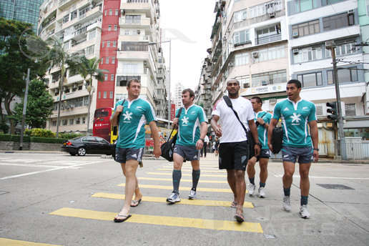
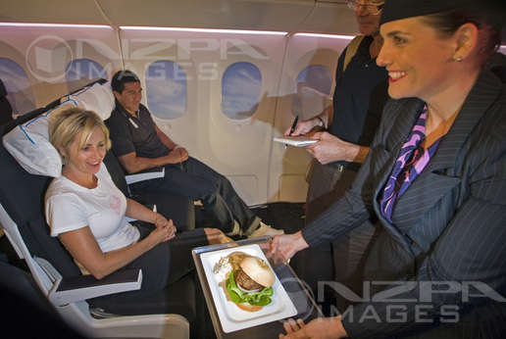
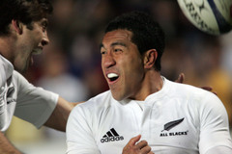
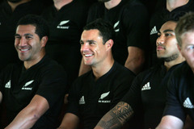
1. What do you infer happened?

…………………………………………………..

2. Evidence

…………………………………………………..
1. Where do you infer Mils is?

…………………………………………………..

2. Evidence

…………………………………………………..
1. What do you infer is happening?

…………………………………………………..

2. Evidence

…………………………………………………..
1. What do you infer is happening?

…………………………………………………..

2. Evidence

…………………………………………………..

TRAINING

In this section you will read about Mils’ time in the New Zealand Sevens team. This time the inferences are made for you. Your challenge is to give the evidence that proves the inference. Are you up for it? Let’s go!
Mils’ coach in the New Zealand Sevens team was Gordon Tietjens. “If you eat well, you will play well”, Gordon told the team. Gordon would sometimes drive to MacDonalds and Burger King to check if any of the players were there. Any player caught with the wrong food was given a growling . . . and extra training!

Inference: Gordon is very strict when it comes to food

Inference: Gordon is very strict when it comes to food

Evidence:

Some players hid biscuits, chips and lollies under their mattresses. Sometimes they said they were going to the toilet but went and bought ice creams. On the night before the 2000 Wellington Sevens Final, Jonah Lomu, Amasio Valence and Mils sneaked off to KFC. ‘I hadn’t had it for so long’, Mils said. ‘I thought it would be alright.’

Inference: the players were sometimes not as serious as their coach about food

Inference: the players were sometimes not as serious as their coach about food

Evidence:

Mils scored an important try in the 2000 Wellington Sevens Final against Fiji. But he felt exhausted after scoring it. Mils had never felt as tired as that during a game. Jonah had a quiet game and was replaced. Fiji won the game 24-14. ‘I should have really sacrificed that trip to KFC,’ Mils later said.

Inference: the KFC affected the way Mils and Jonah played

Evidence:

‘I thought I had let the team down,’ Mils says. ‘That was where I learnt that it wasn’t just about yourself. You’ve got to sacrifice things like KFC to get the best out of yourself, and for the team.’

What do you infer Mils will do the next time he is tempted to eat KFC before a big game? Draw your prediction here:

GAME TIME

An important part of inferring is using your own background knowledge and experiences to help you make guesses. This activity will show you how to do that.

Mils grew up in Invercargill. He attended Cargill High School and later Southland Boys High School. When he was 17, Mils began to drink alcohol with his friends after games. Sometimes they would get into trouble with other groups of young people.

Clues in the text | Your own knowledge | Inference
Mils and his teammates are celebrating another victory. They have been drinking beer in a park. They go to MacDonalds to get some food. Another young person teases Mils in front of some girls. | How do young people who have been drinking sometimes react when they are teased or mocked? | How will Mils react?
Mils and the other young man are fighting. The police arrive. | What usually happens when the police arrive at a fight? | What will the police do to Mils?
Mils’ mother is worried about his behaviour. She feels like she is losing control of him. Mils’ older brother is living in Auckland. He is doing well. | What do parents sometimes do when they feel they can’t control their teenaged children? | What will Mils’ mum decide to do?
Mils is told he is going to stay in Auckland. He will have to leave his family and friends. | How would I feel if I was sent away from home? | How does Mils feel about moving to Auckland?
What do you think will happen next in the story?

EXTRA TIME

Question: What season is it?

Another way to practise inferring is to use the KIS Technique

K – underline Key words
I – make an Inference
S - Support your inference

Example

The All Blacks are playing the Springboks at Eden Park. Mils comes out to check conditions. It has been raining for days. He trudges through mud puddles on the side line. He is wearing a thick track suit. Shivering, he rubs his hands together. His breath is like steam.

Remember the question was: What season is it?

- underline Key words that help answer the question: done
- make an Inference – the season is most likely Winter
- Support your inference
  - It’s been raining for days
  - There are mud puddles
  - He’s wearing a thick track suit
  - He’s shivering
  - He rubs his hands together
  - His breath is like steam

Your turn.

The game is over. Mils skips into the All Blacks changing room. He high fives his teammates. Coach Graham Henry comes in. He shakes Mils’ hand and says, “Well done!”

Question: Who won the game?

- Underline key words that help answer the question.
- make an Inference - ………………………………… won the game
- Support your Inference
  - ……………………………………………….
  - ……………………………………………….
  - ……………………………………………….

WARM DOWN: WRITING
Remember the Who Am I challenge this section began with? Now it’s time for you to try. Choose an All Black or a player from another team. Think of clues you can write to describe the player. Then test a friend!

PLAYER

…………………………………………

CLUES

…………………………………………

…………………………………………

…………………………………………

…………………………………………

…………………………………………

For an extra challenge write in a poetic style like the one at the beginning of this section. You could use rhyme.

If you really feel brave, try writing in similes. Here’s an example:

His tackles feels like thunder pounding your ribs.
When he gets the ball his eyes flash like lightning
He runs around you like a ferocious wind
Or over the top of you like a cyclone

Who do you infer the player is? ………………………………………………………..

