The Lion King

Directed by: Roger Allers

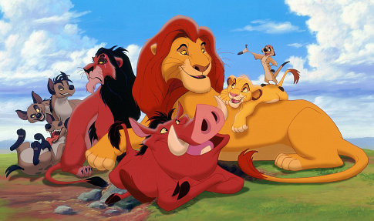

Believe in yourself and never give in to the challenges of life.

Name: ____________________________

PLOT SUMMARY
The film opens with a gathering of countless ________ around ______ _______ in _________, where _________ the mandrill presents the newborn lion cub, ___________, of King _________ and Queen __________. The only resident of the Pride Lands who is not happy in the least about this is _______, Mufasa's younger __________, who desires the throne for himself. Simba grows quickly and is taught everything about the _______ _________, including the neighbouring ___________, ruled by the ruthless ___________ and forbidden for residents of the Pride Lands. When Scar "accidentally" lets slip that the Outlands consist of an __________ Graveyard, Simba and his best friend, __________, outsmart Mufasa's major-domo, ______, venture out into the Outlands and stumble across three hyenas, _______ , ________ and __________ , who promptly try to kill them in the ensuing chase. _________ arrives to rescue the cubs in time, having been alerted by Zazu, and teaches ___________ an emotional lesson in __________ and valour.
Meanwhile, _______ plots with the hyenas to kill both __________ and _______ to take over the Pride Lands. On Scar's orders, the hyenas ignite a _____________ of ____________ in a gorge where Simba is, because Scar told him to stay there. Scar rushes to inform __________, who manages to save Simba but is betrayed and thrown off the cliff by ________, where he hits the ground with great force, is impaled on some of the wildebeest's _________, and is __________. Simba finds his father's lifeless __________ in the middle of the gorge. Scar arrives and tricks Simba into thinking it was he was ____________ for Mufasa's death. Due to the shame of such an act, he encourages Simba to leave the Pride Lands and never ________. Simba immediately turns and runs away, while almost immediately ________ orders the hyenas to follow and ________ Simba. A chase follows but Simba manages to _________. In Simba's absence, Scar uses the opportunity to state that both Mufasa and Simba were killed in the _________ and profess himself as ___________. He takes over the Pride Lands and also allows the _________ entry to the pride.
Simba, however upon fleeing is found collapsing in the wasteland by ________, a meerkat, and __________, a ____________, who nurse him back to health and take him in, teaching him the ways of their motto, "_______ __________”. Years later, once Simba is an __________, he encounters _________, who was trying to maul Timon and Pumbaa. Nala expresses her delight at discovering Simba alive, and informs him of how Scar's _______________ as _________ of the Pride Lands is going to drive everyone into _____________ and eventual __________. Still wracked with _________ over supposedly causing his father's death, Simba refuses to return and overthrow Scar, but ________, having tracked Simba down, leads him to the _________ of Mufasa, which reminds Simba who he is and how he must take his rightful place as ________ of the Pride Lands.
Simba returns with Nala, Timon and Pumbaa. While Timon and _________ distract the hyenas, Simba confronts Scar atop Pride Rock after Scar strikes _________ across the face. Scar turns the tables by revealing that Simba caused Mufasa's end and forcing _______ towards the edge of Pride Rock, where he holds on for dear life. Just before Scar can throw the "traitor" off, he quietly reveals that it was he who __________ Mufasa. In his rage, Simba leaps back up and pins Scar, forcing him to _______ his treachery to the public. A violent _________ ensues between the ________ and _________ while Simba confronts Scar alone at the top of Pride Rock. Scar begs Simba for _______mercy, accusing the _________hyenas of planning the whole thing. Simba prepares to show Scar mercy and exile him, but Scar refuses to give up, and the ensuing fight ends when ________ throws ________ off Pride Rock. He survives the fall, but is immediately mauled to death by the ________, who overheard his disloyal accusations.
With Scar gone and the hyenas banished, Pride Rock is eventually restored to its previous majesty under _________'s rule. The film closes with __________ presenting the animals with Simba and ________ newborn cub.

animals Nala brother Pumbaa trampled corpse bravery Scar Mufasa Ed Scar Pride Rock hyenas Mufasa Elephant Africa Rafiki Pride Lands Simba Scar irresponsibility warthog Simba king escape return Mufasa stampede King Outlands Pumbaa ghost fight hyenas lionesses death guilt Sarabi King wildebeest Scar Mufasa Simba hyenas Simba Sarabi Nala hyenas stampede Nala Simba Shenzi, Banzai Mufasa responsible horns Scar kill Timon Hakuna Matata adult starvation Rafiki murdered reveal Rafiki Nala's

Cast
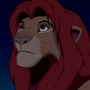 | Character: ________________  Three Adjectives: __________________ , ____________________, ___________________.
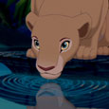 | Character: ________________  Three Adjectives: __________________ , ____________________, ___________________.
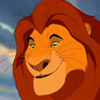 | Character: ________________  Three Adjectives: __________________ , ____________________, ___________________.
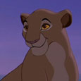 | Character: ________________  Three Adjectives: __________________ , ____________________, ___________________.
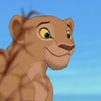 | Character: ________________  Three Adjectives: __________________ , ____________________, ___________________.
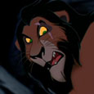 | Character: ________________  Three Adjectives: __________________ , ____________________, ___________________.
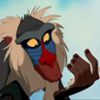 | Character: ________________  Three Adjectives: __________________ , ____________________, ___________________.
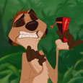 | Character: ________________  Three Adjectives: __________________ , ____________________, ___________________.
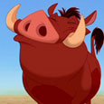 | Character: ________________  Three Adjectives: __________________ , ____________________, ___________________.
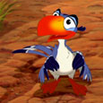 | Character: ________________  Three Adjectives: __________________ , ____________________, ___________________.
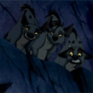 | Characters: ________________, __________________, ___________________  Three Adjectives: __________________ , ____________________, ___________________.

SIMBA
Like any child, Simba’s view of the world and his role in it is rather simple. To him,
growing up to be the Lion King means getting to tell the other animals what to do.

RAFIKI
The baboon shaman Rafiki takes on the task of narrator and spirit guide. Rafiki is the teacher in "The Lion King."

MUFASA
Mufasa guides and teaches Simba. As ready to play as to instruct, Mufasa knows when to chide Simba for his mischief and when to chuckle at it. Strong, brave, and wise, Mufasa is a true leader whose courage comes from a great.

NALA
Every bit as hard to control as Simba, Nala, a lioness cub, is ready to go wherever he goes and do whatever he does.

SCAR
Lean, mocking Scar makes up for his lack of physical prowess with devious cunning. Obsessed
with the need to possess the throne.

TIMON & PUMBAA
Sympathetic and warm-hearted, Pumbaa is ready to trust anyone even a carnivore like Simba.
Pumbaa may have more brawn than brains, but his size includes an oversized heart, too.

The self-proclaimed "brains of the outfit," Timon is a hyperactive meerkat with a motor mouth. Timon always has a fast line. But behind the chatter is a loyal little guy who’d give his last joke to help a friend.

Cast
Characters in Film
Character: 1
Name of Character: __________________________________________________________________________
Physical Description of Character: ______________________________________________________________
__________________________________________________________________________________________
Description of Personality: ____________________________________________________________________
__________________________________________________________________________________________
Relationship to other characters: _______________________________________________________________
__________________________________________________________________________________________
Two examples from the film that show the characters personality: _____________________________________
__________________________________________________________________________________________
__________________________________________________________________________________________

Character: 2
Name of Character: __________________________________________________________________________
Physical Description of Character: ______________________________________________________________
__________________________________________________________________________________________
Description of Personality: ____________________________________________________________________
__________________________________________________________________________________________
Relationship to other characters: _______________________________________________________________
__________________________________________________________________________________________
Two examples from the film that show the characters personality: _____________________________________
__________________________________________________________________________________________
__________________________________________________________________________________________

Character: 3
Name of Character: __________________________________________________________________________
Physical Description of Character: ______________________________________________________________
__________________________________________________________________________________________
Description of Personality: ____________________________________________________________________
__________________________________________________________________________________________
Relationship to other characters: _______________________________________________________________
__________________________________________________________________________________________
Two examples from the film that show the characters personality: _____________________________________
__________________________________________________________________________________________
__________________________________________________________________________________________

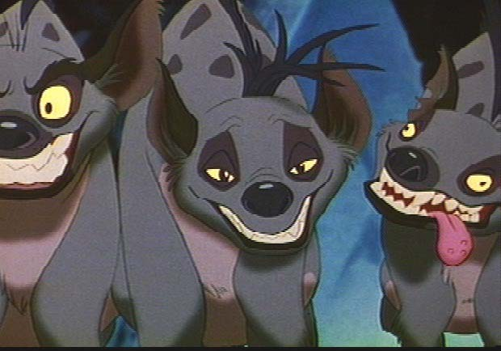

Film Language
Camera Shots
SHOT/ANGLE | EXAMPLE | WHY IS IT USED?
WA / ES / ELS  WIDE ANGLE | 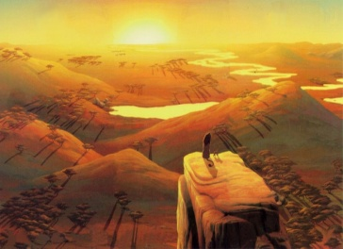 | SETTING  To set the scene (let us know where we are). Contains a lot of landscape and helps establish location and likely atmosphere/context. Often used at the beginning of a film or scene.
LS  LONG SHOT | 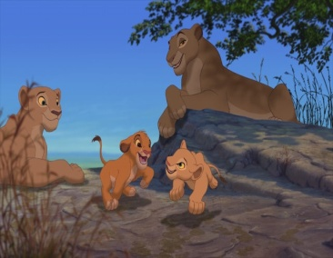 | ACTION  This shot contains a fair amount of background, however figures are slightly more recognisable.
FS  FULL SHOT | 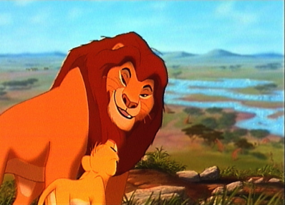 | ACTION  This shot does not contain the whole height of any figure in the frame. Again this shot is primarily used for action and allows the audience to be more personally involved.
MS  MID SHOT | 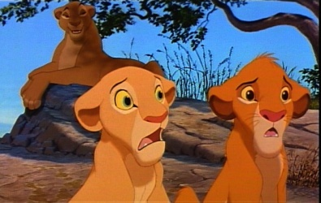 | DIALOGUE  The figures in this shot are seen from the waist up - a comfortable speaking distance (like watching the news).
CU  CLOSE UP | 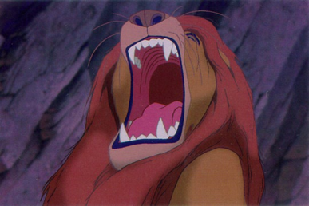 | CHARACTER  A close up gives us almost complete focus on an object or a person’s face. This portrays the emotions of characters.
ECU  EXTREME CLOSE UP | 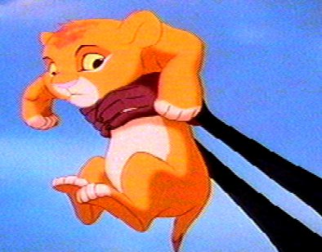 | SYMBOLS/DETAILS  This shot is often used to highlight important symbols in a film. If the focus is a character we will see only part of the person e.g. their eyes or hands.

Camera Angle
ANGLE | EXAMPLE | WHY IS IT USED?
OVER SHOULDER SHOT | 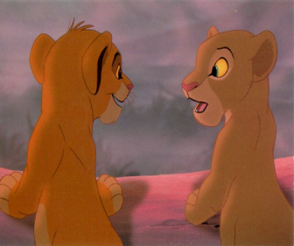 | DIALOGUE  Usually used when characters are in discussion. Allows the audience to get more of a feel for what character might be saying or hearing.
POINT OF VIEW SHOT | 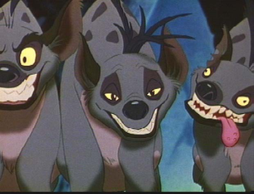 | INVOLVEMENT  This allows the audience to see the action from the point of view of a character. We feel personally involved.
HA  HIGH ANGLE | 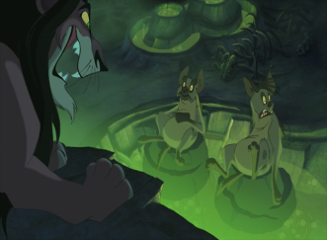 | ISOLATION  This angle is from high looking down but not directly above. The main effect is to make the object look small and lacking in power.
LA  LOW ANGLE | 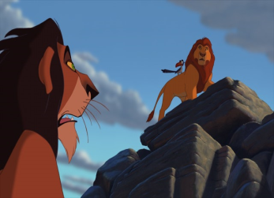 | POWER AND STATUS  The camera is low and looking up at a figure. The main effect is to make the figure look large and powerful, suggesting dominance or status.
EYE LEVEL | 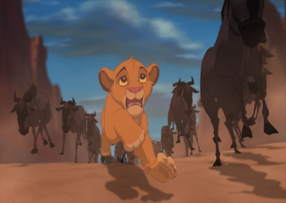 | REALITY  This is the shot that occurs when the camera is level with the object or figure. It is the angle that is most like a normal eye-view of the scene and tends to suggest a real life effect.

Camera Movement
Movement Name | Effect
Tracking | Physically moving the camera with the subject reveals details of the background and shows where the action is taking place.
Crane Shot  Taken from a mechanical device called a crane – carries the camera and operator in any direction. | Gives a smooth swooping look to a shot.
Aerial Shot  Filmed from a plane or helicopter. | show a journey.
Pan Shot  The camera moves from one side horizontally to the other from a fixed point. | a character turning his/her head.
Tilt Shot  The camera moves up or down vertically from a fixed position. | Reveals a view slowly - to imitate someone looking up or down.
Zoom Shot  A zoom lens moves the shot closer to, or further away from the subject in a smooth action. | Focuses attention on something particular in a shot.

Editing (the process of putting a film into its final form)
Editing Techniques | Use and Effect
Cut  The most common transition from one shot to the next. | We see one shot and suddenly we are seeing a different shot.
Fade out /Fade in  The screen goes dark or fades out before the next shot fades in and the details of the next shot become visible. | to show time passing  character has lost or regained consciousness
Dissolve  One shot comes up, as another goes down. | Often used to show a change in location
Wavy Screen  The screen waves as the image dissolves | Sometimes used to indicate a dream

THE LESSONS OF "THE LION KING"

Main Theme: Believe in yourself and never give in to the challenges of life.

Minor Themes:

- LISTEN When Mufasa tells Simba about the family that watch over them, he urges him to "Mamela," or "listen" in the African language Xhosa. Listening is the first, essential part of learning. It is by listening to his elders and those who have experience that Simba grows up and takes his part in the Circle of Life.

- REMEMBER When Simba sees his father’s spirit, Mufasa tells him "Remember." Remember who you are, and where you came from. "The Lion King" can help young people explore their own lives, "remembering" their past and their place in their schools and communities.

- LEARN This is perhaps the most important lesson of "The Lion King": that we can learn from our mistakes. Simba cannot run from his past he has to learn from it; mistakes should be seen as opportunities for discovery and growth.

Visual and Verbal Features /Techniques
Visual Features | Verbal Visual
Camera Techniques: Shot  Wide Angle  Long Shot  Full Shot  Mid Shot  Close Up  Extreme Close Up  Camera Techniques: Angle  Over The Shoulder shot  Point of View shot  High Angle  Low Angle  Eye Level  Camera Techniques: Movement  Tracking shot  Crane shot  Aerial shot  Pan shot  Tilt shot  Zoom shot | Dialogue
Props | Sound Effects
Costume | Music
Special Effects | Use of Silence
Lighting | Voice over
Colour
Use of Settings or Location

Conflicts in Lion King
Films that tell stories often involve conflict situations. The conflict might be:
Between individuals: ________________________________________________________________________
Between groups: ___________________________________________________________________
Internal conflict (such as a character who faces a personal challenge): _________________________________
__________________________________________________________________________________________
__________________________________________________________________________________________
Choose the main conflict in the film you are studying:
Who is involved? ____________________________________________________________________________
What is the cause of the conflict? _______________________________________________________________
___________________________________________________________________________________________
What happens? ______________________________________________________________________________
___________________________________________________________________________________________
___________________________________________________________________________________________
How is the conflict resolved? ___________________________________________________________________
___________________________________________________________________________________________
___________________________________________________________________________________________

Soundtrack
The soundtrack is made up of:
- Sound Effects
- Music
- Dialogue
- Ambient sounds (natural sounds)
- Silence
What effect does the soundtrack have?
____________________________________________________________________________________________
Only listen (don’t watch) to an important scene from your film and note down all the different kind of sounds you can hear.
- ___________________________________________________________________________________
- ___________________________________________________________________________________
- ___________________________________________________________________________________
- ___________________________________________________________________________________
- ___________________________________________________________________________________
- ___________________________________________________________________________________
- ___________________________________________________________________________________
- ___________________________________________________________________________________
- ___________________________________________________________________________________

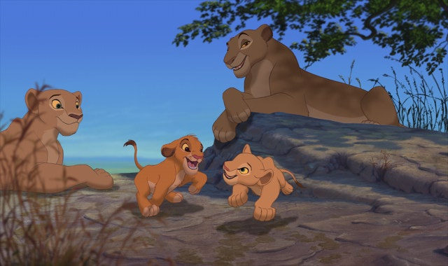

Hidden Message

(figure this out and you will have a theme of the film)

R G O R N A L A O D W I S L H
L O A A L W A Y S T R I A U S
M C C A C O U R A G E Y N P I
S H O K N V E R E V R S E I N
M A N D R I L L L E L H Y W A
G U E D M E M Q V I Z E H I B
M R F A M E H A L I O N E S S
L P A A R Q R T L L N Z M D I
I R K V S B R C O S R I S O M
F I N W E A E L Y R O N T M B
G D J J F Y H Z B A B O O N A
R E X I L E A J J M W B L I B
A M K V E N O R H T E D P L L
S I B A N Z A I D O N E E U Q
S E N M G Z R N B A K G N I K

ANIMALS
BABOON
BANISH
BANZAI
BRAVERY
BROTHER
COURAGE
EXILE
FILM
GRASS
GRAVEYARD
HYENAS
KING
LION
LIONESS
MANDRILL
MERCY
MUFASA
NALA
NEWBORN
PLOTS
PRIDE
QUEEN
RAFIKI
ROCK
SCAR
SHENZI
SIMBA
THRONE
WISDOM
ZEBRA

__ __ __ __ __ __ __ __ __ __ __ __ __ __ __ __ __ __ __ __ __ __ __ __ __

__ __ __ __

Lion King
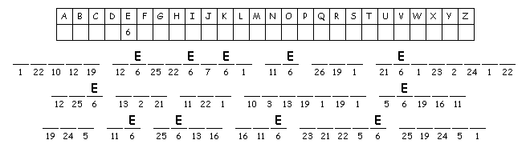

Lion King
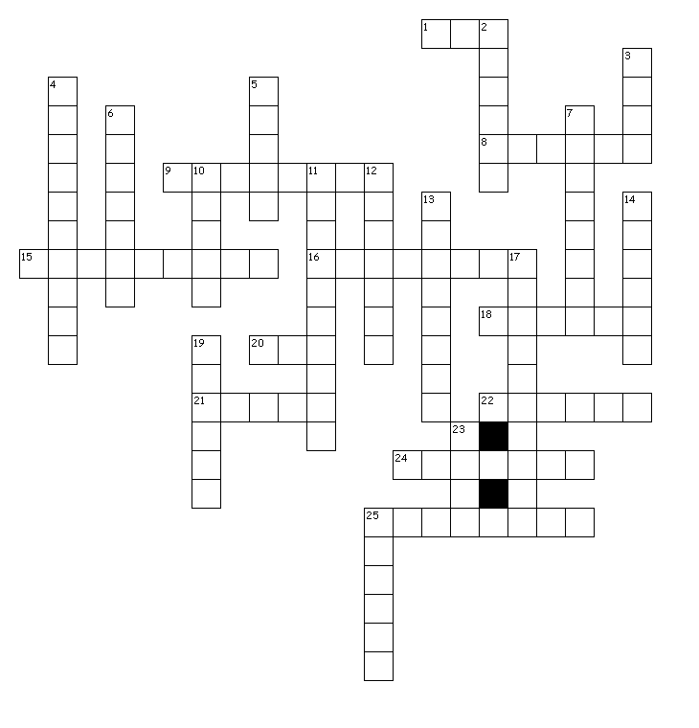

Across
1. young lion
8. continent
9. large number of animals running
15. eats meat only
16. elephant skeletons
18. listen in Xhosa
20. to move from one shot to the next
21. Hakuna Matata
22. baboon
24. eye level shot
25. a series of scenes

Down
2. hyena
3. friend
4. kingdom of Simba
5. idea of the film
6. Wide Angle
7. Mid Shot
10. meerkat
11. first part of the film
12. putting film into its final form
13. covering of a bird
14. scavengers
17. to have little food
19. warthog
23. bird
25. queen

Hidden Message
Good will always triumph over evil
Cryptogram
Simba believes he was responsible for his Mufasa’s death and he left the Pride Lands
Crossword
africa continent
pridelands kingdom of Simba
outlands elephant skeletons
banzai hyena
stampede large number of animals running
cub young lion
timon meerkat
pumbaa warthog
nala friend
motto Hakuna Matata
starvation to have little food
sarabi queen
rafiki baboon
zazu bird
setting Wide Angle
dialogue Mid Shot
editing putting film into its final form
sequence a series of scenes
exposition first part of the film
setting where film takes place
theme idea of the film
mamela listen in Xhosa
cut to move from one shot to the next
reality eye level shot
carnivore eats meat only
hyenas scavengers
feathers covering of a bird

