- Why is this story like a jigsaw puzzle?
- How does the author fit the pieces of the family puzzle together so that it makes sense?
- What is the effect of leaving the family situation unresolved at the end?
- How does Phillipa’s background influence the way she sees the world?
- Find a quote that would reflect Ruth’s personality and a phrase that reflects Ralph’s personality.
- Identify and explain the metaphor used when describing the effects of the drugs on Ruth.
- For each of the following quotations identify:
7a
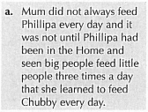
- Who is who speaking?
- What problem are they facing here?
- What is the impact of this problem on Phillipa?
7b
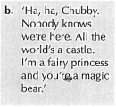
- Who is who speaking?
- What problem are they facing here?
- What is the impact of this problem on Phillipa?
7c
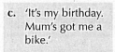
- Who is who speaking?
- What problem are they facing here?
- What is the impact of this problem on Phillipa?

7d
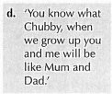
- Who is who speaking?
- What problem are they facing here?
- What is the impact of this problem on Phillipa?

- Explain the theme of ‘using dreams to escape reality’.
- Explain the theme of ‘avoiding responsibility’.
- Explain the theme of ‘abuse of power’
- Explain the theme of ‘role model’
- Explain how Phillipa shows ‘unconditional love’ for her parents.
- Explain how the rag doll and the dustbin can be images of child neglect.
- Explain how a cycle of abuse exists in this home.

