Research Worksheet
Fairies
- Explain in your own words what a fairy is.
______________________________________________________________________________________________________________________________________

List the 7 beliefs as to the origins of fairies and give a brief description of what each folk belief is.

 | Origin of Fairies | Description
1
2
3
4
5
6
7

- Give a brief description of a goblin.
____________________________________________________________________________________________________________________________________________________________________
- Which place in NZ has a goblin related name?
____________________________________________________________________________________________________________________________________________________________________
- Give a brief description of a troll.
____________________________________________________________________________________________________________________________________________________________________

- In 5 lines, summarise the tale of ‘How Kahukura Learned to Make Nets’. (The Book of Elves and Fairies by Frances Jenkins Olcott)
______________________________________________________________________________________________________________________________________
____________________________________________________________________________________________________________________________________________________________________________________________________________________________________________________________________________

Organised Crime
- What term is used to describe criminal organisations around the world?
___________________________________________________________________

- Which organisation first carried this name?
______________________________________________________________________________________________________________________________________

- What name is given to the Japanese organised crime syndicate?
___________________________________________________________________

- List at least 5 well known organised crime syndicates around the world.
_____________________________
_____________________________
_____________________________
_____________________________
_____________________________
Codes
- Define what a code is.
____________________________________________________________________________________________________________________________________________________________________
- Define what a cipher is.
____________________________________________________________________________________________________________________________________________________________________
- Name 3 famous cryptographers and indicate when they lived.
_________________________________________
_________________________________________
_________________________________________
- Write down 5 facts about the ‘Navajo Code’.
_________________________________________
_________________________________________
_________________________________________
_________________________________________
_________________________________________

Synopsis
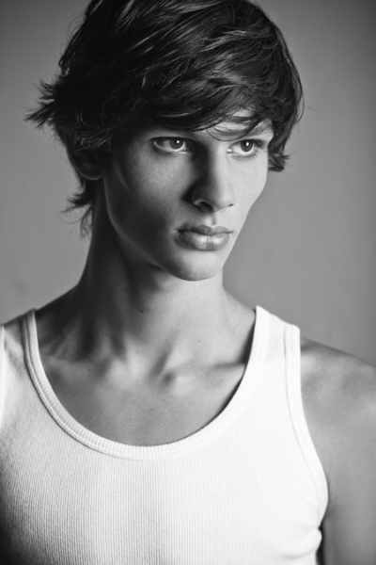
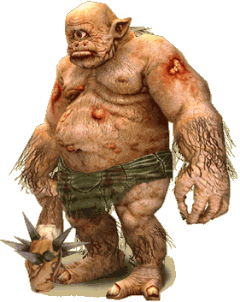
Artemis Fowl II, the title character, is the twelve-year-old son of an Irish crime lord, Artemis Fowl I. After significant research, Artemis believes that he has confirmed the existence of fairies and decides to kidnap one. He tracks down an alcoholic sprite posing as a healer in Ho Chi Minh City, Vietnam, and travels there with his friend and bodyguard Butler to obtain from her The Book of the People—the Fairy holy book that is written in Gnommish.
Meanwhile, Captain Holly Short of the Lower Elements Police is tracking a rogue troll that has managed to reach the surface of the Earth from the fairy city, deep underground. Assisted by a technically minded centaur called Foaly and LEPrecon commander Julius Root, she incapacitates the troll. However, this uses the last of her magic, and Commander Root demands that she complete the magic restoring ritual.
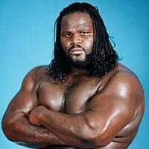
Artemis decodes the Book using computerized translating software, and in the process, learns the specifics of the ritual: taking an acorn from an ancient oak tree near a bend in a river under the full moon and planting it elsewhere. Artemis and Butler track down over 100 possible locations for the ritual and start a stakeout; after nearly four months, they discover Holly performing the ritual. She attempts to use the magical mind-controlling mesmer to defend herself, but Artemis is prepared for this, and Butler tranquilises Holly with a hypodermic syringe. The LEP, who are immediately aware of her disappearance, send Julius Root to search for her. He traces her tracker to an abandoned whaling ship off the coast of Dublin, Ireland. Through an audio/visual communicator, Artemis informs Root from Fowl Manor that he is holding Holly for ransom, then destroys the whaling ship remotely by detonating a large amount of Semtex.
A LEP retrieval team is sent to scout Fowl Manor. Using their magical 'shielding' ability, which allows them to vibrate faster than the human eye can follow, the team enters the manor grounds. Artemis anticipated this also, however, and installed a camera with a high frames-per-second rate, allowing him to detect the threat by freezing the image. After Butler incapacitates the intruders, Root decides to lay siege to Fowl Manor using a time-stop and enter negotiations. The ransom demand is revealed as one metric ton of 24-carat gold. Artemis uses the opportunity to reveal his knowledge of the time-stop and claims that he can escape it.
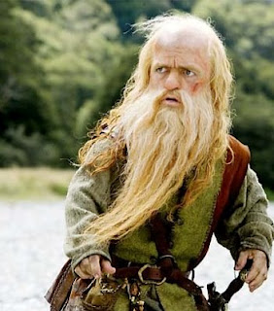
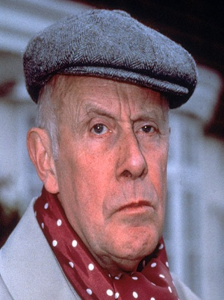
The attempts to gain entry to the manor continue as an infamous criminal, the kleptomaniac dwarf Mulch Diggums, is recruited to break in. Fairies are forbidden from entering human dwellings without permission, but Mulch has already broken this rule and is immune to the adverse consequences. He tunnels underground to reach the house while Foaly feeds a loop to the manor surveillance system, allowing Mulch to freely explore. Mulch locates a safe containing a copy of the Book, finally revealing to the fairies the source of Artemis' knowledge. The Fairy Council, deciding that nothing is working, promote a lieutenant called Briar Cudgeon to Acting Commander, temporarily usurping Julius Root. He sends in a troll in an attempt to elicit a cry for help, which counts as an invitation for fairies to enter. Meanwhile, recalling that she dropped the acorn from the ritual into her boot, Holly Short cracks through the concrete of her cell using her bed and completes the ritual. Having regained her magic, she escapes into the main house.
Butler, aided by the healing powers of Holly, defeats the troll, and Artemis is finally granted the ransom. The gold is sent in, and Artemis asks Holly for a wish: he wants to cure his mother's insanity - she has been living in her bedroom, driven mad by the loss of her husband. Holly grants the wish at the cost of half the gold. The LEP decides to send in a 'blue rinse' - a biological bomb that kills all organic life - to eliminate Artemis and allow for the retrieval of the gold, but this fails when Artemis escapes the time-stop by drugging himself and his comrades with sleeping pills.
When Butler wakes, Artemis explains that by changing one's state of wakefulness in a time-stop, one can escape it, as it is only one's state of consciousness that keeps one trapped by the time-stop. Artemis then discovers that his mother has fully recovered from her insanity thanks to Holly's magic.

Major characters
- Artemis Fowl II – The protagonist; a 12-year-old genius, he uses his intelligence to break the law in order to obtain wealth; this stems down from his family, who have been criminals for generations. Half of him wants to steal from the rich, and the other half wants to give to the poor.
- Butler – The Fowl's manservant and Artemis' bodyguard, but also Artemis's friend and accomplice.
- Captain Holly Short – A determined, first female member of LEPrecon. Compassionate and caring, she goes as far as healing Butler from fatal wounds sustained fighting a troll.
- Commander Julius Root – Known as 'Beetroot' by fellow fairies for his characteristic red face, he is Holly Short's superior officer.
- Foaly – The LEP's technical advisor. Portrayed as brilliant, but highly sarcastic, he is described as 'having few friends'.
- Mulch Diggums – A criminal dwarf who is recruited by the LEP to gain access to Fowl Manor during the siege.

Artemis Fowl Prologue and Chapter I: The Book
1. What was unusual about Artemis Fowl?
2. How did Artemis recognize the waiter as his contact?
3. What happened to the pickpocket?
4. Why was Nguyen given $20,000?
5. Why did Artemis want to see the sprite?
6. What did Artemis do to get the fairy to show him the book?
Artemis Fowl Chapter 2: The Translation
1. Why did Artemis want to find a fairy?
2. Who was Juliet?
3. What did the language in the Fairy Book most resemble?
4. Why was it so difficult for Artemis to shut down all the computers in his father's study?
5. Artemis spent hours trying to decode the Gnommish, the fairy language. Have a little fun with this new way of writing.

Translate the following: Artemis Fowl tricks a fairy into handing him her book of magic.

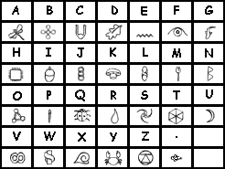

____________________________________________________________________________________________________________________________________________________________________________________________________________________________________________________________________________________________________

Artemis Fowl Chapter 3: Holly
1. Why did Root NOT want Holly on his squad?
2. While Root was talking to Holly he was interrupted by an emergency. What was the
emergency?
3. The Mud People could NOT see Holly because she ----.
4. Why could Holly NOT go into the restaurant at first?
5. To keep the people inside the restaurant Holly -------.

Artemis Fowl Chapter 4: Abduction
1. The ritual to renew fairy powers must take place during a full moon, next to a river bend, and ------------------.
2. Instead of flying over the ocean Holly, ---------.
3. Holly chose to renew her powers --------.
4. Why did Holly's sensors NOT find Artemis and Butler?
5. Why did the mesmer magic not work on Artemis?
6. What happened to Holly after she tried the magic?
Artemis Fowl Chapter 5: Missing in Action
1. How did Commander Root learn of Holly's abduction?
2. How was Root able to track Holly?
3. Who was going to try to rescue Holly?
4. What did Artemis do with the locator band?
5. What did Butler do to pick a fight with the workmen at the dock?
6. How did Root track Holly's locator?
7. What happened to the whaler?
Artemis Fowl Chapter 6: Siege
1. Why did Artemis place the wrist locator in the whaler?
2. At the sound off, Trouble discovered -----.
3. The fairies fought Butler with ---------.
4. What did Butler request after knocking all the fairies unconscious except Grub?
5. Why did Holly not have to obey Juliet when she said, "And there's no need to break up the furniture either."?
6. Commander Root's next plan in saving Holly after Butler fought his Retrieval Squad was -------.
Artemis Fowl Chapter 7: Mulch
1. Mulch tunnelled deep into the earth around the Fowl Manor to avoid ---
2. Mulch used ------------ as a pick to open the lock on the wine cellar door.
3. What problem did Mulch have as he was walking through the hallways of the Fowl Manor?
4. How did Mulch get past the cameras?
5. What was behind the portrait of Artemis Fowl, Senior?
6. What was in the hidden compartment of the safe?
7. Mulch was able to escape by -----.
Artemis Fowl Chapter 8: Troll
1. What plan did Root have for recovering the gold?
2. What plan did Cudgeon have for capturing the humans?
3. How did Chix get the troll out of the cage?
4. Why did Juliet NOT want to go with Butler to the situations room?
5. When the troll was coming up the hall towards him, Butler hid in -----.
6. How was the troll defeated?

Artemis Fowl Chapter 9: Ace in the Hole
1. What was the purpose of sending the troll into the Fowl Manor?
2. Why did Cudgeon miss all the excitement?
3. What happened to the fairies as they entered the manor after setting off the bio bomb?
4. What caused Root and Grub to become sick?
5. What happened to the recovered ransom?
6. How was Angeline Fowl effected by the kidnapping and rescue?
Film Director Task
You are a famous and successful director of many famous films. You have been asked to turn the book ‘Artemis Fowl’ into a film.
You have been asked to summarise what the novel is about and explain why it will make a good film. Write your notes for the pitch using the following table.
Novel Title
Short Summary of Book | _________________________________________________________  _________________________________________________________  _________________________________________________________  _________________________________________________________  _________________________________________________________
Three reasons why the book would make a great film. | 1. _______________________________________________________  _________________________________________________________  _________________________________________________________  2. _______________________________________________________  _________________________________________________________  _________________________________________________________  3. _______________________________________________________  _________________________________________________________  _________________________________________________________

Casting the Characters
Choose one character and write instructions for your actors so they understand the role. Use the following starters.
1. This character _________________ is important in the story because ____________________________________________________________________________________________________________________________________________________________________________________________________________________________________________________________________________________________________
2. An important moment in the novel which involves the character is when ____________________________________________________________________________________________________________________________________________________________________________________________________________________________________________________________________________________________________
3. At this point the character would be thinking that
____________________________________________________________________________________________________________________________________________________________________________________________________________________________________________________________________________________________________
4. The character would be feeling ______________________________________________
_________________________________________________________________________

Draw any setting of the text.
Map

Planning to communicate the theme(s) of your novel.
Good novels and good film adaptations have a clear message (or theme) which gives their readers or viewers something to think about. Answer the questions following to clarify your thinking about the message or theme of your production.
1. The message or theme of the novel is
____________________________________________________________________________________________________________________________________________________________________________________________________________________________________________________________________________________________________
2. An important moment in the story which shows this is
____________________________________________________________________________________________________________________________________________________________________________________________________________________________________________________________________________________________________
3. At the end of the novel I think the author wanted the reader to feel
____________________________________________________________________________________________________________________________________________________________________________________________________________________________________________________________________________________________________
4. I am going to convey that same feeling as in the film by means of the following:
- The last shot will be
____________________________________________________________________________________________________________________________________________________________________________________________________________________________________________________________________________________________________
- The music at the end will be
____________________________________________________________________________________________________________________________________________________________________________________________________________________________________________________________________________________________________
- I chose this music because
____________________________________________________________________________________________________________________________________________________________________________________________________________________________________________________________________________________________________

Board Game

The People's Paper
Imagine you are a newspaper editor for the People. News of the robbery has reached you. Your job is to produce the front page using the template below:
Things you have to do:
- Give the paper a name. (A masthead is the name of the paper.) Think about names that already exist for papers and how they could be adapted. For example, instead of the 'Northern Echo' you could have the 'Underground Echo'. Remember that newspaper names are usually three words or less.
- Think of a headline that will grab the audience. (Remember that alliteration is very popular in headlines.) You also need to keep in mind what the readers would know and what they wouldn't. For example, 'Attack on Artemis' would not be very good because most fairies would have no idea who he is.
- Write the text for the story. Start with the most important information, which in this case is that half a ton of gold has been lost. Include interviews with relevant people. Think about who could have something to say. For example, what would Foaly say to reporters?
A list of points you want to make would help you at this stage. Write down, in' point form, things you think should be included and then number them in the order you want to mention them. For example, one point you might like to put in your story is the fact that Artemis gave back half of the gold. However, this isn't the most important point, so it wouldn't be number one.

- Decide on some images that you can use to go with the story. Make sure that they add something to it. You might include a picture of Fowl Manor, for example.
- Add a caption to the picture.
- Think of a company that might advertise in the paper and write their advert in the box. Remember that the People are not exactly like humans. For one thing, they live much, much longer.

Response to Text Essay
Question: ____________________________________________________________________________________________________________________________________________

- Always plan your response first –
  - Think of at least 2 ideas
  - Find examples in the text to back your ideas up.

- Use the information about essay writing and paragraph structure to help you complete this task.
PLAN

Introduction
Your introduction should echo the question/topic, state your point of view and introduce the main points you will discuss in the body of your essay.

Body
The main part of your essay is divided into paragraphs. Each point you discuss should been written as a separate paragraph. Keep your argument going by referring back to the initial question/topic and give supporting detail to back up what you say. Structure your ideas logically and connect the paragraphs with linking words or phrases. Use SEXY structure your paragraph appropriately.

Conclusion
Your conclusion should reinforce your point of view about the question/topic. It should restate your main points and should end with a strong, thought-provoking statement/question.
You will be assessed at Level 4/5 of the NZ Curriculum using the following criteria:
 | Working Towards | Achieved | Merit | Excellence
Audience and Purpose | Some awareness of audience impacts on choice of language.  Tends to describe rather than analyse. | Language and writing style appropriate to audience and task but still more description than analysis. | Language and writing style appropriate to the audience and task.  Explains relevance of key elements of text. | Audience’s expertise acknowledged through use of content.  Evaluates relevant key elements.
Ideas | Mostly a plot retelling with strong emphasis on personal response. Material is repetitive or not relevant. Not long enough to address task adequately. | Personal response dominates. Attempts to use details of text but not analysing in relation to task. Usually describing and often repetitive. | Uses some elements (plot, character, setting and theme) to explain task.  Includes relevant details and quotes. Uses appropriate personal response. | Uses elements to interpret aspect of text required by task.  Integrates evidence from text. Uses appropriate personal response.
Structure | No paragraphs. Mostly simple sentences. | Uses paragraphs. Mix of simple and compound sentences. | Uses paragraphs. Has introduction & conclusion and uses linking words. Uses some complex sentences too. | Organised with evidence of thought to placement of material and transitions between paragraphs. Variety of sentence types.
Conventions | Too many mistakes with basic spelling and punctuation. | Some spelling and punctuation errors. | Few spelling and punctuation errors. | No spelling and punctuation errors.

Comment:

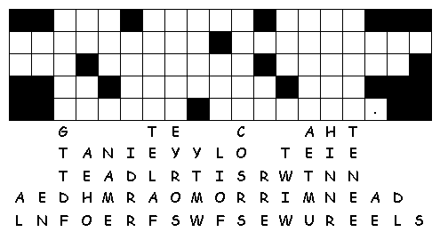
Artemis Fowl
