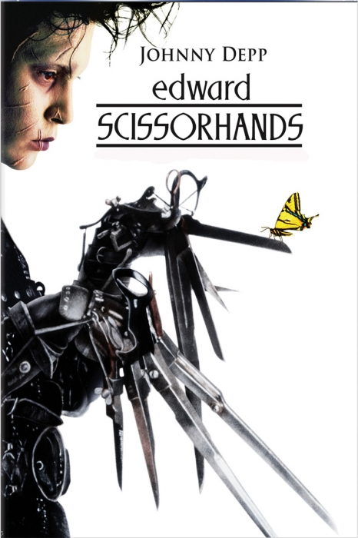

Name : ____________________________________
Edward Scissorhands – Plot Summary

Fill in the gaps in the Plot Summary using the words in the box below:

Edward ______________is a movie about a character who wants to ___________ things but cannot actually ____________ them.

Edward is the _____________ of the ________________. He lives alone in a dark ______________ on the hill above a ___________ American suburb.

He is discovered by ______________ , a housewife and local _______ representative. Peg is unfazed by Edward’s _______________ appearance and immediately decides that Edward should come ______ with her.

Edward is taken in by Peg’s family and his arrival creates a ______ of excitement in the neighbourhood.

He shows he is skilled at creating _______________ designs and soon the suburb is full of his work. He then moves on to clipping _______ and then creates new and _______ hairstyles for the local ___________.

Edward is ______________ with Kim, the Boggs’ daughter, but she finds him ___________ . Her _____________, Jim, laughs at Edward and views him as a ____________.

Jim gets Edward into trouble making him break into Jim’s father’s room to get _____________. Edward only does this because he thinks _______ wants him to.

Kim realises that she is __________ in love with Edward and that Jim is _____________.

Jim is ____________ and tries to take his revenge but ends up nearly killing __________. Edward tries to help Kevin, but the neighbours ______________ his actions and turn on him. They are ____________ on by Joyce, whose advances Edward had earlier _______________.

Edward is chased back to the house on the hill and there is a final _______________ between him and ______ which ends in tragedy.

Kim realises that in order to ____________ Edward she must trick the neighbours into thinking that Edward is ___________. She does this by showing them a ____________, and saying that the ________ had fallen in on him.

The movie closes with Kim as an _____ woman telling the story about _______ to her granddaughter, and we see Edward alone in his mansion ______________ ice statues to create snow for Kim, showing that his undying __________ for her goes on forever.

old love Scissorhands snow

scissorhand dead protect

feel touch confrontation Kim

money Jim Inventor creation

pastel Peg Boggs Avon roof

Kevin misinterpret urged no-good

bizarre home topiary stir

smitten dogs wild weird

housewives money freak boyfriend

rejected carving falling jealous

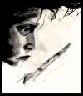
Edward Scissorhands
Viewing Questions

General
- How would your life be if you were noticeably different from everyone around you?

- What if you had a substantial physical or mental disability? How would it affect your daily activities, your relationships with family and friends, and your plans for the future, your feelings?

- How would you feel about yourself? How would you want to be treated?

Viewing Questions

- Describe the images during the introduction. What do you see?

- What atmosphere does the music and the images create?

- Explain the purpose of colour used in the opening of the scene of the movie.

- Describe the people in this neighbourhood. What is your opinion of them?

- What contrast do you notice as Peggy, the Avon Lady, approaches the mansion on the hill?

- Describe the atmosphere in front of the mansion.

- What did you expect to find inside the gates of the mansion?

- Once you see inside, how does this contrast represent the difference between appearance and reality?

- Are people the same inside as they are outside?

- What do the neighbours talk about when Peggy brings Edward to her house? What is your opinion of them?

- What might be the symbolic meaning of Edward’s wearing black leather clothes?

- List the different incidents that show how Edward adjusts to Peggy’s house.

- What do you think about the first day he spends in Peggy’s house?

- What do you predict about his future life there?

- How would you feel if you were in his place and why?

- What does the can-opener remind Edward of?

- What do you think the heart cookie means?

- Describe the neighbours’ attitude toward Edward at the barbecue party.

- What is your reaction to Joyce’s statement that Edward is "not handicapped, just exceptional"?

- Describe Kim’s return home.

- Describe Kevin’s “Show and Tell” at school.

- What is interesting about the hair-styles Edward makes?

- Give examples that show how Edward feels about Kim.

- What is Kim’s conflict?

- What does Peggy think Edward did when she sees him at the police station?

- Why doesn’t Edward explain anything to Bill and Peggy?

- Why don’t the neighbours want to go to Peggy’s Christmas dinner?

- Why do they lie and gossip?

- What is your opinion of the neighbours now? Have they changed or stayed the same since the beginning? Explain.

- When Peggy says to her daughter that she hadn’t thought things through, do you agree with her? Do you think Edward has to go back to his own world?

- What is your reaction toward Edward’s memory of his inventor’s Christmas present?

- What is your opinion about Kim’s telling Edward to “run” after he saves her brother’s life?

- Compare Jim and Edward.

- Was the ending of the movie inevitable? How do you feel about Edward at the end and why?

Basic Camera shots, Terms and Angles

The following are basic shots, terms and angles most commonly used in film. The explanations are general and do not necessarily explain every specific shot in every film.

SHOT/ANGLE | EXAMPLE | WHY IS IT USED?
WA / ES / ELS  WIDE ANGLE | 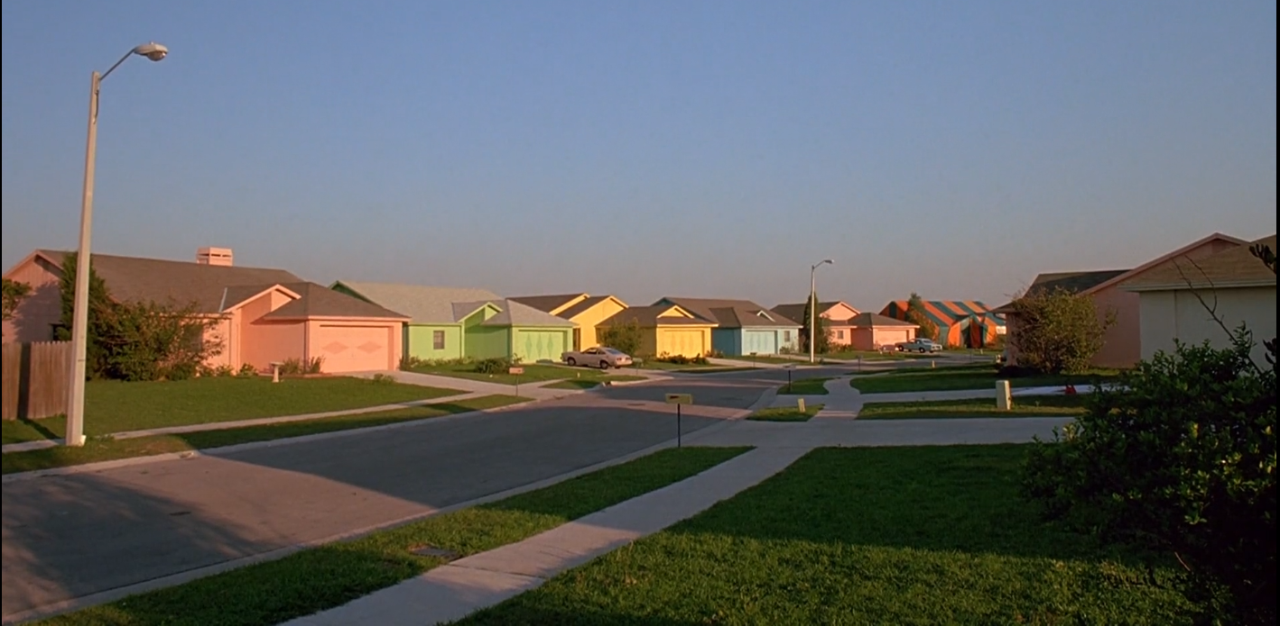 | SETTING  To set the scene (let us know where we are). Contains a lot of landscape and helps establish location and likely atmosphere/context. Often used at the beginning of a film or scene. Landscape when shown like this becomes symbolic or thematic.
LS  LONG SHOT | 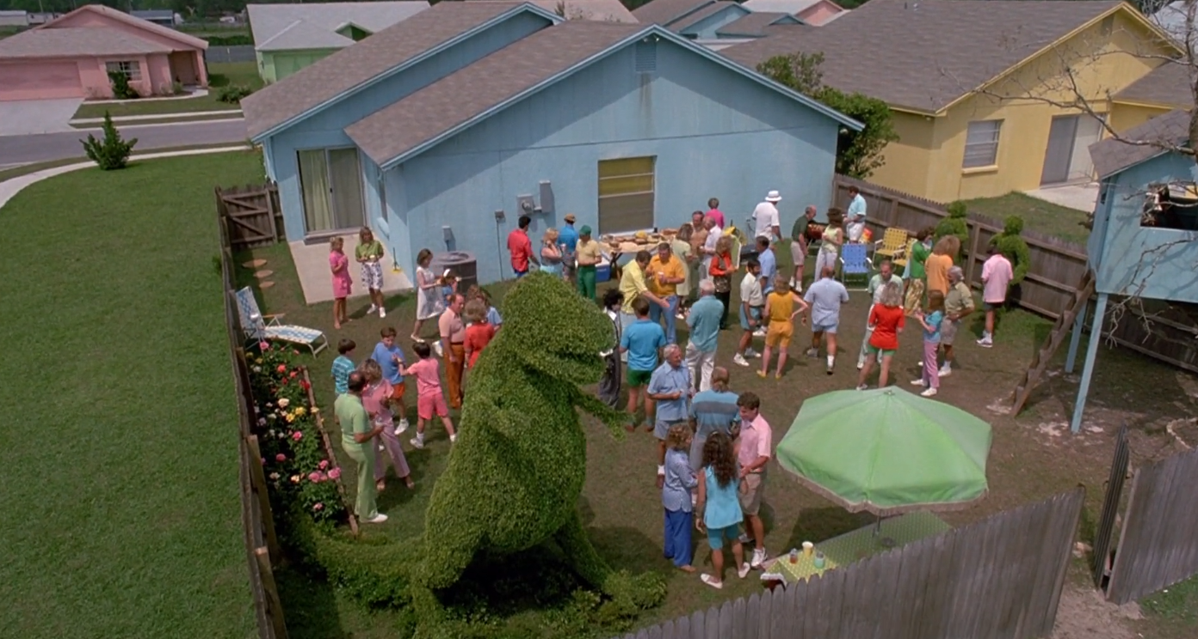 | ACTION  This shot contains a fair amount of background, however figures are slightly more recognisable. This shot is often used for action. It allows us to see a big picture and mass movement.
FS  FULL SHOT | 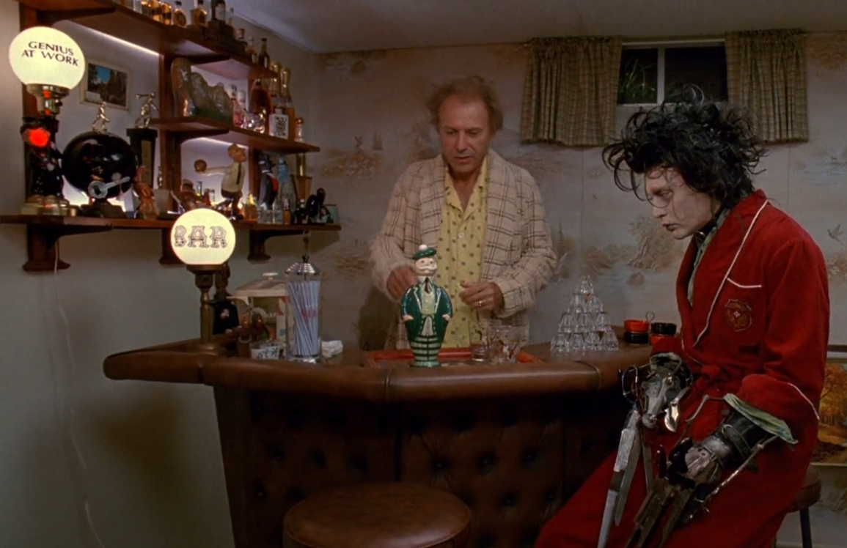 | ACTION  This shot does not contain the whole height of any figure in the frame (if it contains two figures it’s called a two-shot). Again this shot is primarily used for action and allows the audience to be more personally involved. Here it links the character to his/her physical setting/context.
MS  MID SHOT | 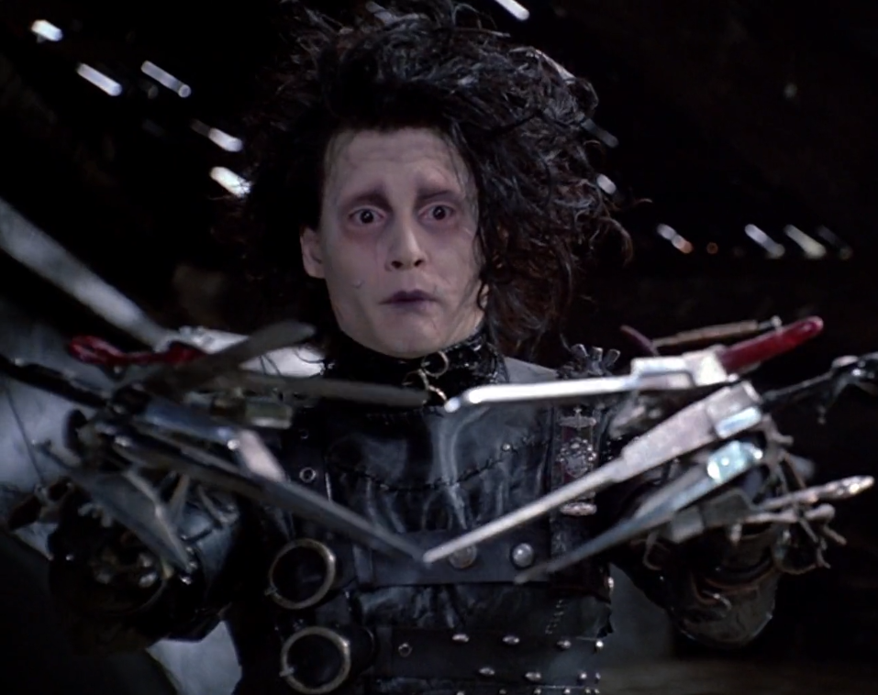 | DIALOGUE  The figures in this shot are seen from the waist up. Often characters talk in these shots as this what we would personally regard as a comfortable speaking distance.
CU  CLOSE UP | 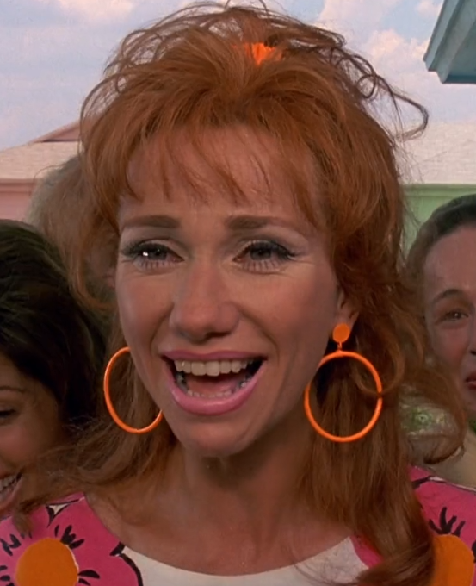 | CHARACTER  A close up gives us almost complete focus on an object or a person’s face. This shot enables directors/actors to portray the emotions of characters and create atmosphere and feeling.
ECU  EXTREME CLOSE UP | 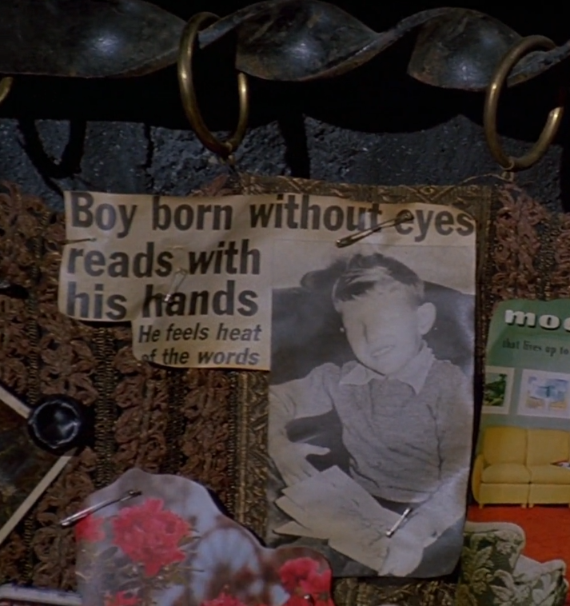 | SYMBOLS/DETAILS  This shot is often used to highlight important symbols/ideas in a film. If the focus is a character we will see only part of the person e.g. their eyes or hands. This shot focusses on how a blind boy has done something remarkable.

SHOT/ANGLE | EXAMPLE | WHY IS IT USED?
OVER SHOULDER SHOT | 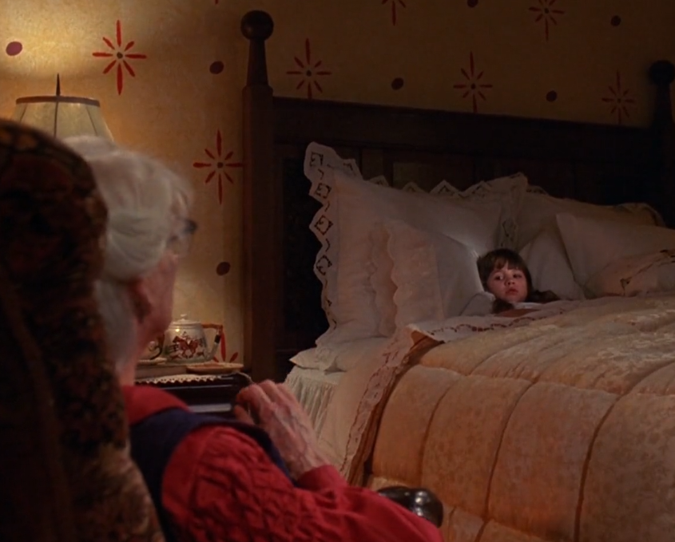 | DIALOGUE  Usually used when characters are in discussion. Allows the audience to get more of a feel for what character might be saying or hearing. It helps us to feel more involved in the dialogue. Reverse Angle Shot – alternate over the shoulder shot, shows viewpoint of the speaker and then the reaction of the listener.
POINT OF VIEW SHOT | 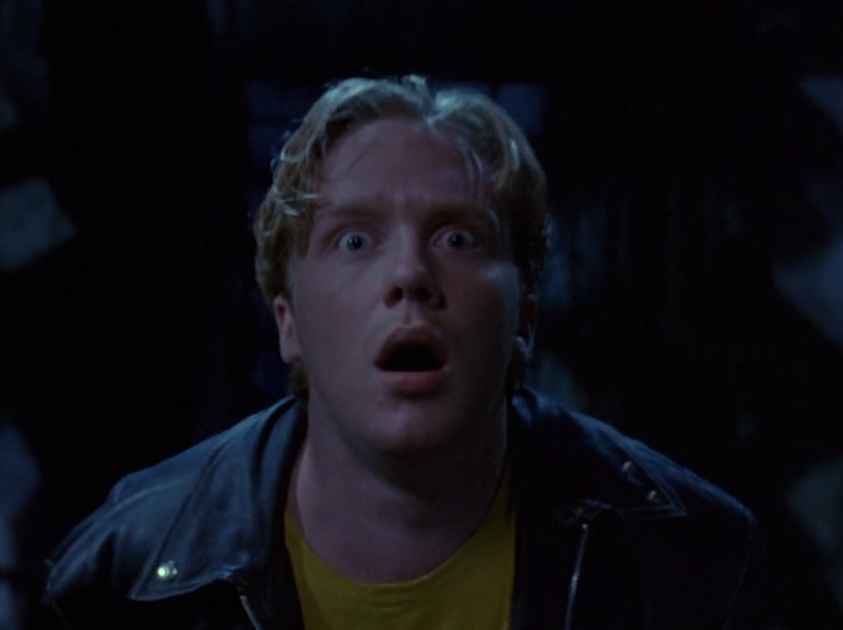 | INVOLVEMENT  Sometimes called a subjective shot, this allows the audience to see the action from the point of view of a character. We feel personally involved.
HA  HIGH ANGLE | 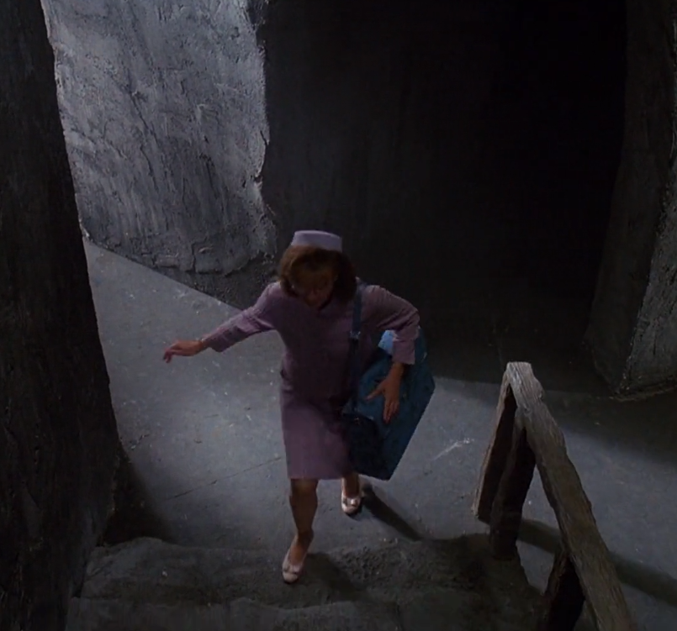 | ISOLATION  This angle is from high looking down but not directly above. The main effect is to make the object look small and lacking in power. It suggests vulnerability of a character.
LA  LOW ANGLE | 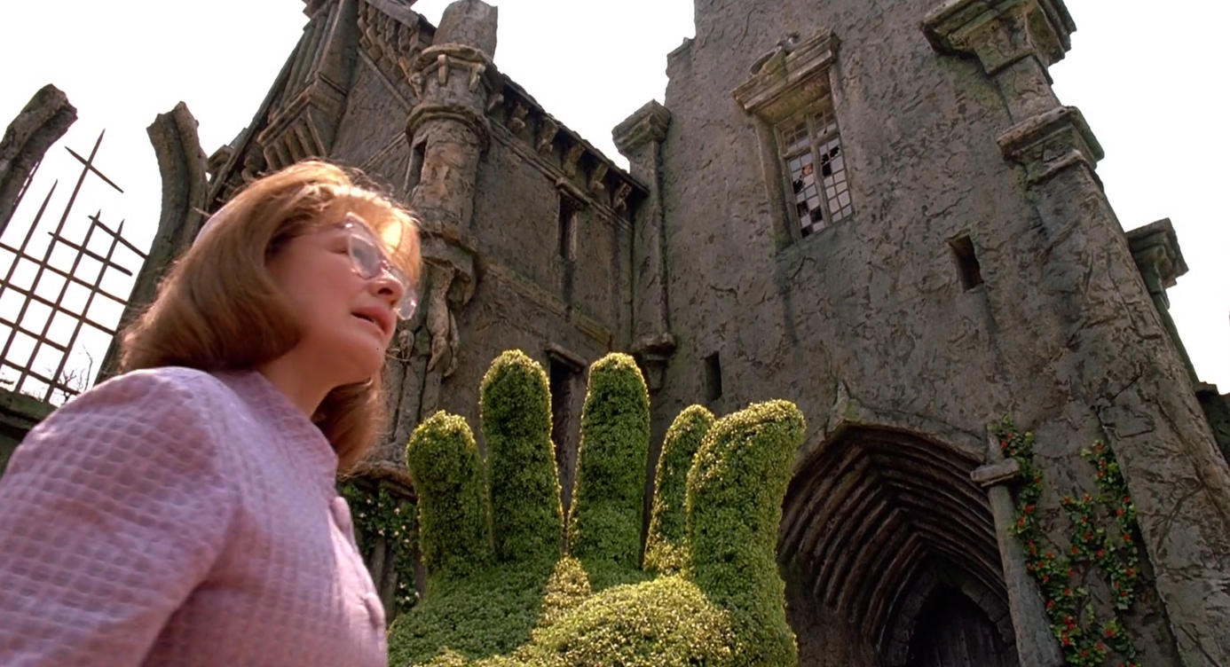 | POWER AND STATUS  The camera is low and looking up at a figure or place. The main effect is to make the figure look large and powerful, suggesting dominance or status. Seen often in this film when Edward’s castle is shown.
EYE LEVEL | 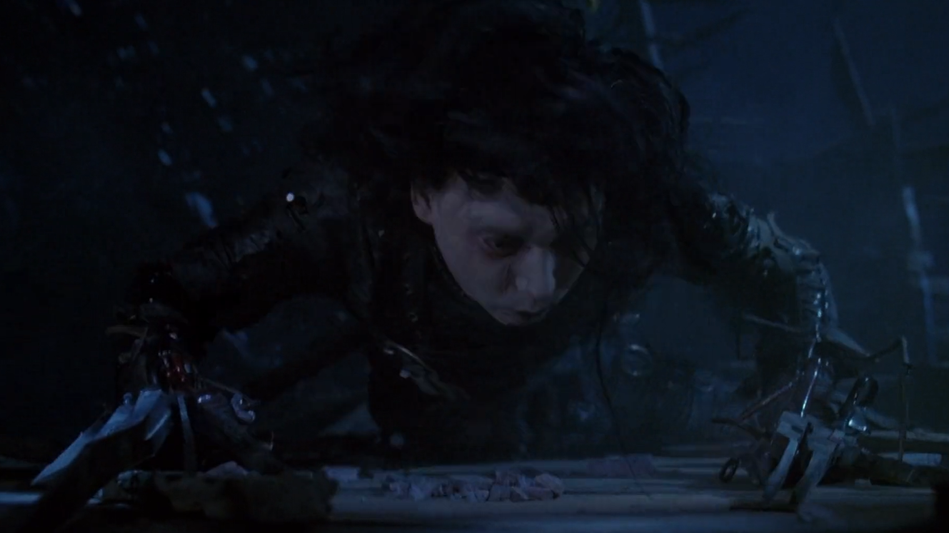 | REALITY  This is the shot that occurs when the camera is level with the object or figure. It is the angle that is most like a normal eye-view of the scene and tends to suggest a real life effect. Edward’s being beaten and his position on the floor.

Camera Movement

Movement Name | Effect
Tracking (Dolly Shot)  The camera physically moves to follow the action. | Physically moving the camera with the subject reveals details of the background and shows where the action is taking place. Hand held tracking gives movement a jumpy feeling and is also done to give a feeling of realism.
Crane Shot  Taken from a mechanical device called a crane – carries the camera and operator in any direction. | Gives a smooth swooping look to a shot.
Aerial Shot  Filmed from a plane or helicopter. | Can be used as an establishing (extreme long shot) or to show a journey.
Pan Shot  The camera moves from one side horizontally to the other from a fixed point. | Reveals a view slowly – imitates the view as seen by a character turning his/her head.
Tilt Shot  The camera moves up or down vertically from a fixed position. | Reveals a view slowly - to imitate someone looking up or down.
Zoom Shot  A zoom lens moves the shot closer to, or further away from the subject in a smooth action. | Focuses attention on something particular in a shot. Creates a sense of movement.

Editing (the process of putting a film into its final form)
Editing Techniques | Use and Effect
Cut  The most common transition from one shot to the next. | We see one shot and suddenly we are seeing a different shot.
Fade out /Fade in  The screen goes dark or fades out before the next shot fades in and the details of the next shot become visible. | A fade is a strong break in the film – often ides between different scenes to show time passing. Can also be used to show a character has lost or regained consciousness.
Dissolve  One shot comes up, as another goes down. | Often used to show a change in location or to show things happening simultaneously. It can also show time passing or aspects of character.
Wavy Screen  The screen waves as the image dissolves | Sometimes used to indicate a dream, a flashback or loss of consciousness.

Music and Sound Effects

Soundtrack Consists of dialogue, sound effects and music. It should reveal something about the scene that visual images don’t.

A. Diegetic Sound
Sound that is present as an actual part of the scene
- voices of characters
- sounds made by objects/character in the story
- music played by an instrument or other source seen in the film e.g. a character singing or playing an instrument
B. Non-diegetic Sound
Sound that is added later and not part of the actual scene
- narrator's commentary
- sound effects which are added for the dramatic effect
- mood/background music (The music in a film is known as the film score)

Toolbox for describing music when close reading film

Tempo | How fast is the music? | Slow or fast
Pitch | What pitch does the music have?  A soprano’s singing is usually high-pitched; bass voices sing at a low pitch. | High or low
Rhythm | What note patterns does the music have? | complicated or simple  fast / slow
Timbre | What tone quality does the music have? | Dark or bright
Dynamics | What is the volume of the music?  This term refers to the relative loudness or softness of the music or its volume. A gradual increase of loudness is called a CRESCENDO; a gradual decrease in volume is a DECRESCENDO. | Loud or soft
Mood | What feeling is developed by the music? | Happy, sad, mysterious
Style | What era does the music come from or type of music is it? | Contemporary, classical, jazz, rock, pop
Instrumental | What instruments are used? | Strings, drums, brass
Melody | What melody is there? | Interesting, unmelodic, simple, complex

Film music serves to:
- establish atmosphere, time and place
- move the action forward
- describe character
- accompany scene changes
- add to the dramatic impact
- provide continuity across edits

Film music composers often use leitmotifs to help build a sense of continuity. A leitmotif is a recurring musical idea (a melody, rhythm or a combination of these) which is associated with a particular idea, character or place)
Leitmotifs are manipulated to match the action and mood of a scene.

Lighting

Strongly influences the way the film looks and feels. Lighting effects are created by the use of artificial lights, natural lighting and reflection, and the use of colour filters.

Light and Lighting Techniques in Film

Lighting is one of the major elements in a film and is basically responsible for the fact that we see any image on the screen at all.

But, in more specific ways, lighting is responsible for both the quality of the images and for much of the film's dramatic effect.

Lighting is responsible for significant effects in each scene.
- attention it can draw to major areas of interest
- lighting can give depth to a scene
- it can bringing out texture and detail in setting, decor, and clothing.
- affects the appearance of a character, defining or diminishing facial characteristics and making faces appear attractive or unattractive.
- lighting is responsible for the mood and atmosphere of individual scenes as well as the entire film.

In general, there are two basic types of luminaires (sources of light)
- the floodlight, which gives a large area of diffuse illumination. It covers a wider area with a more diffuse light, diminishes outline and clarity of characters, minimizes shadow, and reduces modelling of detail and texture.
- the spot-light, from which a beam can be focused to light or highlight a specific area. It clearly illuminates areas, sharply outlines and illuminates characters, brings out detail and texture, and markedly separates light and shadows.
- Various pieces of equipment help to create the desired lighting effects; filters control the colour of light rays; and portable reflectors soften and diffuse light.

Basic setup of lighting
- The key light is the major luminaire that illuminates the subject of the image and is normally placed to the front and side of the subject.
- The fill light is generally placed on the opposite side and fills in the shadows of the subject.
- The third luminaire in this traditional configuration is the back light, which highlights the edges of the subject and separates it from the background.

There are numerous variations of this basic kind of lighting. Terms commonly used in describing the dominant style of lighting for a scene are:
- High-key lighting indicates a brightly lit scene with a minimum of shadows and a key light that is bright and dominant.
- Low-key lighting indicates a scene where the lighting is more towards the greyer and darker scale, where there is a good deal of shadow, and where the key light is less bright and does not dominate.
- A scene, however, with strong contrast between bright light and shadow, with a small amount of in-between grey scale, is called 'high-contrast' lighting.

The general effect of a character's appearance is significantly determined by the angle or direction of the key light.
- Front lighting flattens out the face, diminishes contour and detail, and softens or even blurs the features – such lighting can diminish the appearance of aging or make a person more attractive, but it can also make the face somewhat characterless.
- Back lighting does not bring out details in the face, but highlights the edges of a character, creating a kind of rim or halo around the head and especially the hair while separating the individual from the background; as a result it tends to make the character more angelic.
- Top lighting bathes the character in light, as if the illumination were coming from heaven, giving them an angelic or spiritual appearance.
- Bottom lighting shadows and distorts the face, making it appear sinister, threatening, or evil.
- Side lighting can highlight only half the face, leaving the other half relatively undefined or in shadow, thus suggesting a two-sided or mysterious personality.

In general, bright, clear, even illumination creates a mood of happiness, joy and security, and is therefore frequently used for comedy.

More diffuse, greyer lighting can convey inclement weather and communicate a more sombre and unhappy spirit.

Greyer light with more shadows is effective in mystery films, film noir, or horror films; high-contrast lighting can be effective in drama or thrillers.

Dramatic contrasts in light and shade (chiaroscuro) are often used to heighten tension or create an atmosphere of fear or threat.

Visual and Verbal Features /Techniques (Summary)
Visual Features | Verbal Visual
Camera Techniques: Shot  Wide Angle  Long Shot  Full Shot  Mid Shot  Close Up  Extreme Close Up  Camera Techniques: Angle  Over The Shoulder shot  Point of View shot  High Angle  Low Angle  Eye Level  Camera Techniques: Movement  Tracking shot  Crane shot  Aerial shot  Pan shot  Tilt shot  Zoom shot | Dialogue
Props | Sound Effects
Costume | Music
Special Effects | Use of Silence
Lighting | Voice over
Colour
Use of Settings or Location

Conflict Task Sheet

The main element that drives any film story (or book) is conflict. Without it, there isn't much of a story.

Conflict is a problem or struggle in a story that triggers action, i.e. which causes things to happen.
It can be very obvious, like people fighting, or much less obvious, as when someone worries over what is the right thing to do. This second kind is called 'internal conflict'.

There are six basic types of conflict:
- Person against person: one character has a problem with one or more of the other characters.
____________________________________________________________________________

____________________________________________________________________________

____________________________________________________________________________

____________________________________________________________________________
- Person against society: a character has a problem with some aspect of society: the school, the law, the accepted way of doing things, etc.
____________________________________________________________________________

____________________________________________________________________________

____________________________________________________________________________

____________________________________________________________________________
- Person against self: a character has a problem deciding what to do in a particular situation, or is torn between two (or more) courses of action, or between right and wrong.
____________________________________________________________________________

____________________________________________________________________________

____________________________________________________________________________

____________________________________________________________________________
- Person against Nature: a character has a problem with some natural occurrence: a snowstorm, an avalanche, the bitter cold, or any other element of nature.
____________________________________________________________________________

____________________________________________________________________________

____________________________________________________________________________

____________________________________________________________________________

Person against Fate: a character has to battle what seem to be forces beyond human control. Whenever the problem seems to be a strange or unbelievable coincidence, fate can be considered the cause of the conflict. ____________________________________________________________________________

____________________________________________________________________________

____________________________________________________________________________

____________________________________________________________________________
- Person against machine: a character has to confront technology or other elements of human creation (as opposed to natural or divine creation).
____________________________________________________________________________

____________________________________________________________________________

____________________________________________________________________________

The first few scenes of any film should show us the conflicts and problems the main character will face, and perhaps indicate or hint at what might cause more conflicts later.
- Think about the first part of the film, up to when they leave on the river trip. What conflicts have been established so far?
____________________________________________________________________________

____________________________________________________________________________

____________________________________________________________________________

____________________________________________________________________________
- What other conflicts develop as the film continues? How are these conflicts resolved by the end of the film?
Set this out in two columns, one headed 'conflicts', the second headed 'resolution'.
 | Conflicts | Resolutions
1
2
3
4
5
6
7
8
9
10

Edward Scissorhands
Setting worksheet

- Where is the film set?

- When is the film set?

- Select three settings and describe them, find quotes and then explain how they reinforce specific themes in the film.
3.1
______________________________________________________________________________________________________________________________________________________________________________________________________________________________________________________________________________________________________________________________________________________________________________________________________________________________________________________________________________________________________________________________________________________________________________________________________________________________________________________________________________________________________________________________________________________________________________

3.2
______________________________________________________________________________________________________________________________________________________________________________________________________________________________________________________________________________________________________________________________________________________________________________________________________________________________________________________________________________________________________________________________________________________________________________________________________________________________________________________________________________________________________________________________________________________________________________
3.3
______________________________________________________________________________________________________________________________________________________________________________________________________________________________________________________________________________________________________________________________________________________________________________________________________________________________________________________________________________________________________________________________________________________________________________________________________________________________________________________________________________________________________________________________________________________________________________

Aspect | Scene:
Diegetic sound

Non-diegetic sound
How does it make you feel? Can you describe it? Is it fast or slow? What mood is it?
Colour
What colours are used? What are the associations? Are they similar or do they change?
Lighting
How is light used? Is it constant or does it change?

Camera angles/editing
How does the camera work? Is it close or far away from the characters? Does it stay the same or does it change?
Characters
What do you notice about the way the characters look? How do they move? What do you learn about them?

Film Terms
ambient sound | background sound (not music e.g. bushes rustling): footsteps etc. to match action = FOLEY effects
animation | The process of assembling drawings to be photographed one frame at a time, to create an illusion of movement. Cartoons are best-known form of animation.
art director | The designer of sets and costumes.
aural bridge | hearing the sound of the next shot before cutting to it - signals a transition
auteur | A director (or occasionally some other type of film-maker) with a recognisable style and view of life.
backlighting | Light from behind a person or object, sometimes creating a halo effect.
body language | The way our feelings are expressed through our body.
camera angle | The angle at which the camera is pointed at a person or object (high, low, neutral = eye-level). A camera tilted to one side so the horizon is on a slant is canted or tilted, sometimes called a 'Dutch angle'; not to be confused with a 'tilt shot', which involves camera movement.
cinematographer | A movie cameraman, usually the 'director of photography'.
close-up [C.U.] | A camera shot that seems to bring us close to the person or object being filmed; a shot of a person's face only is a 'close-up'. + 'Extreme Close Up' [E.C.U.] or 'Big Close Up' [B.C.U.].
continuity | The script supervisor keeps a record of 'takes' to make sure that the details are consistent from one shot to another (e.g. a character must be in the same clothes if a scene is shot over several days).
crane shot | A shot taken from a crane (a kind of extreme high angle shot).
credits | The list of cast, crew, and other people involved in making a film. 'Head credits' at beginning; 'tail credits' at end.
cross-cutting | The alternating of shots from two different sequences, often in different locales, suggesting they are taking place at the same time.
cut | The place where one shot has been spliced to another.
cut-away | A brief shot inserted into a sequence showing something connected with the sequence but outside the action, e.g. a shot of the audience watching a show or a game that is being filmed.
deep focus | Every object is in focus to a great depth. See shallow focus
dissolve | One image fades in while another fades out, so that they are superimposed for a few moments.
dolly | A platform with wheels that allows the camera to be moved: 'dolly shot', 'tracking' or 'trucking' shot.
dub | To record dialogue after a film has been shot, usually replacing one language with another.
editing | The process of selecting, arranging and trimming the various shots to make up a film.
establishing shot | Usually a long-shot, it gives an overview of a scene so the audience is not confused about what is happening and where. [EST.]
fade-in | An image appears out of blackness, gradually brightening to full strength. Fade-out = image fades to black
film noir | A French term ('black cinema') for a genre of thrillers in which the universe is despairing and fatalistic.
flashback | A return to a scene in the past. (A flash forward = a future scene shown before it happens.)
focus | The sharpness of an image. To focus a camera is to adjust the lens so that it gives a sharper image.
footage | The amount of film used, or to be used (measured in feet or metres).
frame | A term used to refer to: 1. any single image of a film (there are 24 frames per second)  2. the rectangular shape of the image (like the 'frame' of a painting).
freeze frame | A single frame repeated many times so it looks like a still photograph.
gaffer | The chief electrician in charge of the lights. His/her assistant is the 'best boy'.
genre | A type of film (e.g. western, sci-fi.).
grain | The texture of the film emulsion. A film image with coarse texture is said to be 'grainy'.
hand held camera | The camera is sometimes held in the hand, even though a tripod gives smoother results. See Steadicam.
high key lighting | Bright lighting, usually provided by one source of light (the 'key light').
inpoint | The detail or image at the beginning of a scene, selected for its impact, or because it provides a smooth transition from the previous scene to the new scene. See OUTPOINT.
insert [cut in] | A detail shot (for example a close-up of a letter), or a brief shot inserted into a sequence showing something connected with the action, perhaps as a reminder of what has happened, a hint of what might happen, or something which will become important. An insert differs from a cutaway in that the cutaway is of action not covered in the master shot.
jump cut | An abrupt transition between shots, usually deliberate, which is disorienting in terms of time and space; a startling transition that requires a leap of the imagination. Originally (and still) used for bad cuts within the same scene. Peter Jackson uses the term 'crash cut' for really shocking jumps.
location | A place, other than a studio, where a film is shot.
long lens | A lens with a long focal effect that has a telescopic effect.
long shot /L.S. | A shot from a distance - it shows a person from head to foot, and perhaps more than this.
master shot | A long take of an entire scene, into which other shots e.g. reaction shots, are cut.
matte | A process of combining several images during the printing process (e.g. to add a background).
medium [mid] shot | [M.S.] A shot between a close-up and a long shot in the sense of closeness it creates.
mise en scène | Getting a scene together, the choices made about the details of the imaged; what items will be in it, and how those items are to be presented.
montage | A fast-moving sequence in which many shots are combined – to create a mood, or to sum up a long process, to suggest connections. A series of short clips which add up to more than the sum of the whole. Compresses a passage of time into brief symbolic or typical images.
morphing | Transforming from one image into another
outpoint | The final detail or image in a particular scene. It may sum up what has happened, add a touch of irony, or point towards the following scene. See INPOINT
off camera [O.C.]  out of shot [O.S.] | A character speaks while the camera looks elsewhere. Not the same as voice over. Also known as 'out of shot' [O.S.]
over-shoulder shot | A camera position often used in dialogue scenes, usually alternated to show the character who is speaking.
pan | The movement of the camera when it swivels from left to right or right to left
point-of-view shot [POV shot] | A shot in which the camera is associated with the eyes of a character ('this is what s/he sees'). very useful for helping the viewer identify with a character.
pull focus | To shift focus from one part of a scene to another (also known as 'follow focus' or 'rack focus')
reaction shot | A shot that shows a person's reaction to what happened in the previous shot. (It is known as a 'noddy' if the person is merely nodding, such as a television interviewer!)
reverse angle | A shot from the opposite side. When two people talk, there is often a 'shot and reverse shot' alternation.
rough cut | The first edited version of the film, like a rough copy. It is revised to become the final cut.
screenplay | A film or television script.
set-up | The position of the camera and lighting, selected for a particular shot.
shallow focus | Objects in foreground will be sharp; those in background will be blurred or softened. Opposite = deep focus.
shooting/ filming | The 'shoot' is the period of time spent filming.
shot | A film is made up of many different shots. During the shooting of a film, a shot ends when the camera is turned off. Each shot involves a different camera set-up. During and after the editing of the film a shot ends where the editor has cut it off. See TAKE.
side lighting | Light coming from one side – can create sense of volume, bring out surface tensions, fill in unlit areas.
Skycam | A lightweight camera is suspended via wires and pulleys and controlled from a computer.
soft focus | Opposite of sharp focus, sometimes produced by filters or Vaseline to add a romantic effect.
sound mix | The combination of different elements (dialogue, music, sound effects) to make up the sound track
sound effects | Sounds other than words.
special effects [SFX] | Creating illusions by the use of trick photography, miniature models and various types of equipment. A bomb can explode; a flying saucer can appear, thanks to SFX.
split screen | Two or more separate images within the same frame.
Steadicam | The camera is attached to a vest on the camera operator who can then move it without jerkiness.
still | A single photograph, the enlargement of one frame.
storyboard | A script presented as a serious of drawings and captions.
sub-text | A person's private thoughts and feelings which may be different from those expressed publicly.
synchronisation | Matching sounds with visuals. When words match the movements of the lips, the film is 'in sync'.
subjective shot | A point of view shot, sometimes distorted to emphasise the character's state of mind.
take | One attempt at a shot. To get the effect wanted, the director may ask for more than one version or 'take'. Same as 'shot' but it refers more narrowly to the period when the film is being made.
telephoto lens | A long lens with a telescopic effect.
texture | A term used to refer to: (1) the actual physical look of a film image, those qualities that allow us to distinguish it from a video image or an oil painting, or other kind of image. (2) richness of detail – clouds, faces, wind tugging at clothes, cars passing in the background, etc.  To respond to texture is to notice not just the main meaning or the main objects in a film scene, but also to notice details, colours and surfaces.
threnody | an unnerving sound, signalling a change of mood (threnody = song of lament)
tighter shot | A closer shot, leaving less space around the people or objects on which the camera is concentrating.
tilt shot | The stationery camera starts at the top of an object/figure and scans down to the bottom [tilt down) or at the bottom and scans to the top [tilt up]. Only the lens moves; when the whole camera is lifted = crane shot.
tracking shot | The camera moves on a 'dolly', enabling it to follow people who are moving along.
two-shot | A shot in which two people are shown (cameramen also speak of 'one-shot' and 'three-shot').
video | Television filming. The images are recorded not on film stock, but on videotape.
visuals | The images of a film.
voice over [VO] | Commentary by an unseen narrator.
wide-angle lens | A lens with a broad angle of view, increasing the sense of depth and distance.
wipe | An optical effect in which one image appears to push the previous image off the screen.
zoom | A lens that can be adjusted from 'wide-angle' to 'telephoto'. Such a lens can 'zoom in' or 'zoom out' (seem to move closer or further away from an object).

